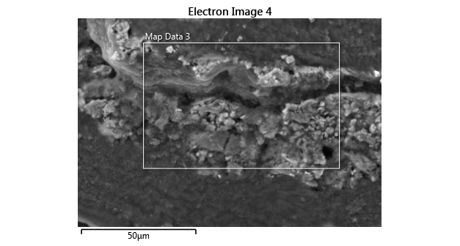

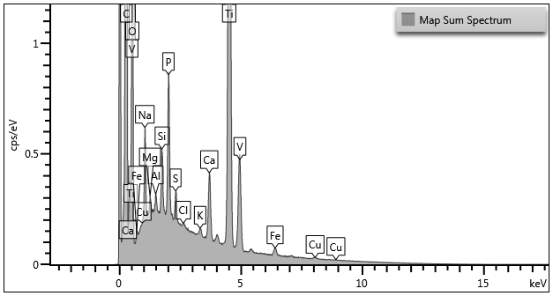

|  |  |
| --- | --- |
| Label: | Map Sum Spectrum |
| Source: | Acquired |
| Created: | 5/8/2020 10:58:24 PM |
| Livetime: | 1672.5s |
| Process Time: | 5 |
| Accelerating Voltage: | 15.00kV |
| Magnification: | 3194 x |
| Working Distance: | 4.8mm |
| Specimen Tilt (degrees): | 20.0 |
| Elevation (degrees): | 35.0 |
| Azimuth (degrees): | 0.0 |
| Number Of Channels: | 2048 |
| Energy Range (keV): | 20 keV |
| Energy per Channel (eV): | 10.0eV |
| Detector Type Id: | 15 |
| Detector Type: | X-Max |
| Window Type: | SATW |
| Pulse Pile Up Correction: | Succeeded |
| Primary Detector: | EDS1 |
| Primary Detector Serial Number: | 60979X050 |

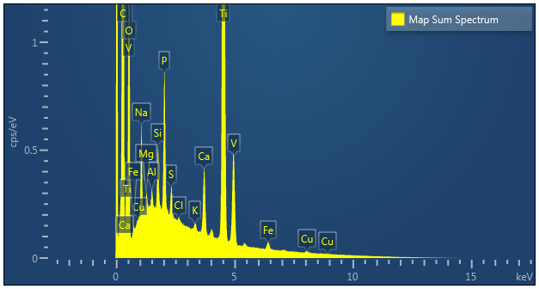

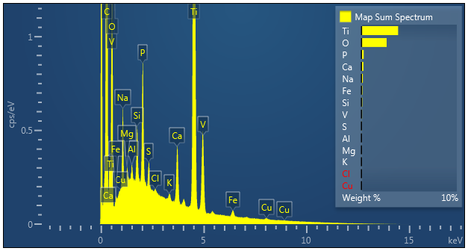

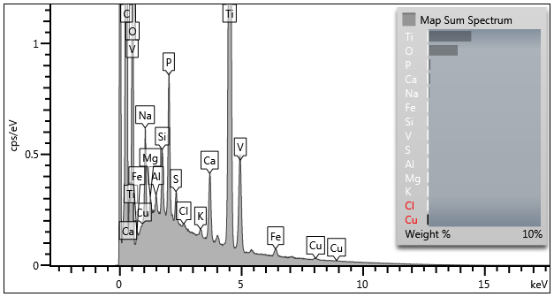

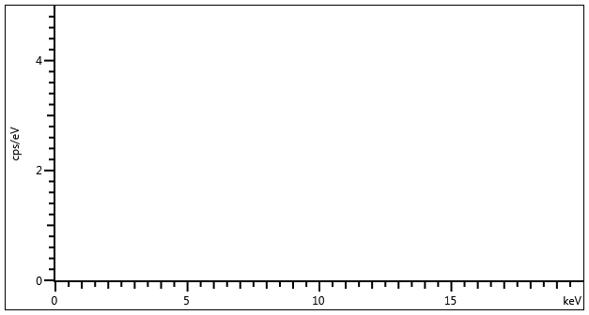

|  |  |  |
| --- | --- | --- |
| Element | Wt% | Wt% Sigma |
| O | 2.64 | 0.01 |
| Na | 0.15 | 0.00 |
| Mg | 0.02 | 0.00 |
| Al | 0.02 | 0.00 |
| Si | 0.08 | 0.00 |
| P | 0.23 | 0.00 |
| S | 0.06 | 0.00 |
| Cl | 0.01 | 0.00 |
| K | 0.02 | 0.00 |
| Ca | 0.20 | 0.00 |
| Ti | 3.84 | 0.01 |
| V | 0.07 | 0.00 |
| Fe | 0.10 | 0.00 |
| Cu | -0.01 | 0.00 |
| Total: | 7.45 |  |

|  |  |  |  |  |  |  |  |  |
| --- | --- | --- | --- | --- | --- | --- | --- | --- |
| Element | Line Type | Apparent Concentration | k Ratio | Wt% | Wt% Sigma | Standard Label | Factory Standard | Standard Calibration Date |
| O | K series | 1.69 | 0.00570 | 2.64 | 0.01 | SiO2 | Yes |  |
| Na | K series | 0.17 | 0.00074 | 0.15 | 0.00 | Albite | Yes |  |
| Mg | K series | 0.02 | 0.00013 | 0.02 | 0.00 | MgO | Yes |  |
| Al | K series | 0.02 | 0.00017 | 0.02 | 0.00 | Al2O3 | Yes |  |
| Si | K series | 0.09 | 0.00072 | 0.08 | 0.00 | SiO2 | Yes |  |
| P | K series | 0.36 | 0.00204 | 0.23 | 0.00 | GaP | Yes |  |
| S | K series | 0.06 | 0.00052 | 0.06 | 0.00 | FeS2 | Yes |  |
| Cl | K series | 0.01 | 0.00007 | 0.01 | 0.00 | NaCl | Yes |  |
| K | K series | 0.02 | 0.00021 | 0.02 | 0.00 | KBr | Yes |  |
| Ca | K series | 0.24 | 0.00218 | 0.20 | 0.00 | Wollastonite | Yes |  |
| Ti | K series | 3.46 | 0.03457 | 3.84 | 0.01 | Ti | Yes |  |
| V | K series | 0.06 | 0.00063 | 0.07 | 0.00 | V | Yes |  |
| Fe | K series | 0.08 | 0.00084 | 0.10 | 0.00 | Fe | Yes |  |
| Cu | L series | 0.00 | -0.00003 | -0.01 | 0.00 | Cu | Yes |  |
| Total: |  |  |  | 7.45 |  |  |  |  |

|  |  |
| --- | --- |
| **General Information** |  |
| Label | Map Sum Spectrum |
| Acquisition Date | 5/8/2020 10:58:24 PM |
| **Acquisition Conditions** |  |
| Live Time (seconds) | 1672.5 |
| Real Time (seconds) | 1927.2 |
| Process Time | 5 |
| Energy Range (keV) | 20 |
| Number Of Channels | 2048 |
| Energy per Channel (eV) | 10.0 |
| Accelerating Voltage (kV) | 15.0 |
| Magnification | 3194.0 |
| Working Distance (mm) | 4.8 |
| Specimen Tilt (degrees) | 20.0 |
| **Spectrum Information** |  |
| Spectrum Area (counts) | 5892730.0 |
| Spectrum Count Rate (cps) | 3057.6 |
| Pulse Pile Up Correction | Succeeded |
| **Strobe Information** |  |
| Strobe Resolution (eV) | 36.59 |
| Strobe Area (counts) | 17040432.0 |
| **Energy Calibration Information** |  |
| Calibration Date | 3/11/2020 6:15:24 PM |
| Calibration Peak | Cobalt K Series |
| Gain Calibration (eV/channel) | 9.9817 |
| **Beam Calibration Information** |  |
| Calibration Date | 3/11/2020 4:52:27 PM |
| Calibration Peak | Cobalt K Series |
| Peak Area (counts) | 212914.0 |
| Process Time | 6 |
| Live Time (seconds) | 42.5 |
| **System Configuration** |  |
| Detector Type | X-Max |
| Primary Detector | EDS1 |
| Primary Detector Serial Number | 60979X050 |
| Window Type | SATW |
| Processor Type | XStream2 |
| Azimuth (degrees) | 0.0 |
| Elevation (degrees) | 35.0 |