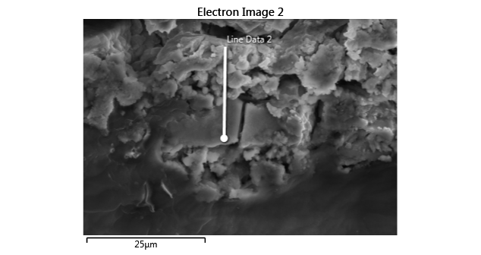

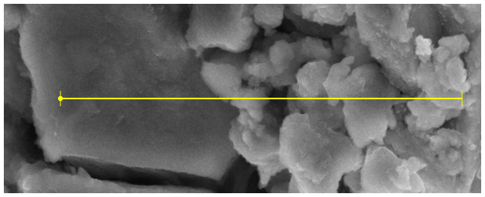

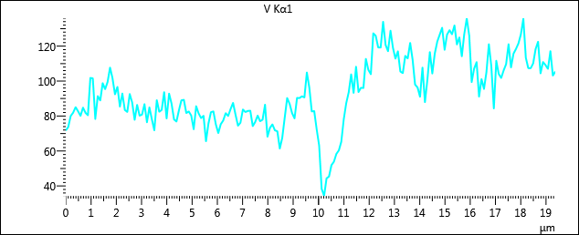

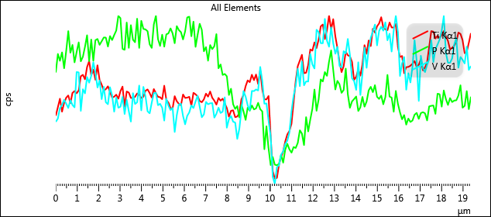

|  |  |  |  |  |  |
| --- | --- | --- | --- | --- | --- |
| **Point** | **Distance (µm)** | **Ti Kα1** | **P Kα1** | **V Kα1** | **Total** |
| 1 | 0 | 472.45 | 152.61 | 71.68 | 696.74 |
| 2 | 0.097396 | 504.56 | 169.46 | 73.68 | 747.70 |
| 3 | 0.19479 | 536.59 | 163.25 | 80.01 | 779.85 |
| 4 | 0.29219 | 487.63 | 170.87 | 81.93 | 740.43 |
| 5 | 0.38958 | 521.08 | 156.50 | 85.04 | 762.62 |
| 6 | 0.48698 | 540.43 | 172.39 | 82.67 | 795.49 |
| 7 | 0.58438 | 549.03 | 190.23 | 80.07 | 819.33 |
| 8 | 0.68177 | 519.72 | 170.62 | 84.80 | 775.15 |
| 9 | 0.77917 | 558.48 | 177.68 | 81.89 | 818.05 |
| 10 | 0.87656 | 565.66 | 161.86 | 80.39 | 807.91 |
| 11 | 0.97396 | 557.08 | 171.28 | 101.80 | 830.16 |
| 12 | 1.0714 | 568.19 | 180.02 | 101.58 | 849.78 |
| 13 | 1.1688 | 621.63 | 162.78 | 78.30 | 862.71 |
| 14 | 1.2661 | 627.12 | 166.93 | 91.39 | 885.44 |
| 15 | 1.3635 | 610.16 | 175.93 | 88.89 | 874.98 |
| 16 | 1.4609 | 656.44 | 186.44 | 98.77 | 941.66 |
| 17 | 1.5583 | 679.17 | 162.97 | 95.35 | 937.49 |
| 18 | 1.6557 | 625.42 | 182.57 | 99.49 | 907.48 |
| 19 | 1.7531 | 646.74 | 163.23 | 107.68 | 917.66 |
| 20 | 1.8505 | 608.36 | 181.98 | 101.58 | 891.92 |
| 21 | 1.9479 | 663.10 | 183.13 | 92.43 | 938.65 |
| 22 | 2.0453 | 607.51 | 177.70 | 96.66 | 881.87 |
| 23 | 2.1427 | 589.78 | 181.00 | 85.41 | 856.18 |
| 24 | 2.2401 | 567.19 | 184.44 | 92.85 | 844.49 |
| 25 | 2.3375 | 572.87 | 184.37 | 83.48 | 840.72 |
| 26 | 2.4349 | 583.69 | 176.21 | 82.31 | 842.20 |
| 27 | 2.5323 | 562.15 | 185.75 | 92.58 | 840.47 |
| 28 | 2.6297 | 541.14 | 182.06 | 87.67 | 810.87 |
| 29 | 2.7271 | 544.20 | 186.66 | 77.86 | 808.72 |
| 30 | 2.8245 | 551.89 | 190.85 | 86.35 | 829.09 |
| 31 | 2.9219 | 536.60 | 204.09 | 80.20 | 820.89 |
| 32 | 3.0193 | 565.30 | 202.00 | 80.80 | 848.10 |
| 33 | 3.1167 | 582.50 | 174.07 | 86.77 | 843.34 |
| 34 | 3.2141 | 505.69 | 173.22 | 76.42 | 755.33 |
| 35 | 3.3115 | 563.95 | 198.04 | 84.94 | 846.93 |
| 36 | 3.4089 | 559.97 | 175.01 | 78.13 | 813.10 |
| 37 | 3.5063 | 539.69 | 195.65 | 71.84 | 807.18 |
| 38 | 3.6036 | 538.74 | 182.45 | 89.03 | 810.21 |
| 39 | 3.701 | 543.79 | 180.05 | 82.44 | 806.27 |
| 40 | 3.7984 | 556.63 | 201.50 | 83.49 | 841.62 |
| 41 | 3.8958 | 551.22 | 174.96 | 93.63 | 819.81 |
| 42 | 3.9932 | 539.19 | 199.55 | 78.61 | 817.35 |
| 43 | 4.0906 | 543.93 | 192.23 | 92.80 | 828.96 |
| 44 | 4.188 | 566.68 | 191.79 | 87.11 | 845.59 |
| 45 | 4.2854 | 571.70 | 190.15 | 78.03 | 839.88 |
| 46 | 4.3828 | 558.20 | 178.28 | 76.84 | 813.32 |
| 47 | 4.4802 | 540.67 | 174.99 | 83.27 | 798.92 |
| 48 | 4.5776 | 573.30 | 196.31 | 88.99 | 858.60 |
| 49 | 4.675 | 557.67 | 204.40 | 89.26 | 851.34 |
| 50 | 4.7724 | 543.72 | 182.95 | 81.72 | 808.39 |
| 51 | 4.8698 | 542.28 | 176.75 | 82.58 | 801.61 |
| 52 | 4.9672 | 534.68 | 186.97 | 80.25 | 801.90 |
| 53 | 5.0646 | 585.91 | 176.11 | 72.44 | 834.45 |
| 54 | 5.162 | 532.13 | 187.32 | 85.62 | 805.06 |
| 55 | 5.2594 | 521.94 | 188.17 | 81.49 | 791.60 |
| 56 | 5.3568 | 500.75 | 192.77 | 78.80 | 772.32 |
| 57 | 5.4542 | 500.33 | 188.18 | 80.13 | 768.64 |
| 58 | 5.5516 | 546.17 | 179.24 | 65.58 | 790.99 |
| 59 | 5.649 | 527.08 | 194.82 | 75.72 | 797.61 |
| 60 | 5.7464 | 517.07 | 191.18 | 82.20 | 790.45 |
| 61 | 5.8438 | 511.58 | 189.28 | 82.63 | 783.49 |
| 62 | 5.9412 | 552.83 | 182.65 | 75.20 | 810.68 |
| 63 | 6.0385 | 539.49 | 189.97 | 70.20 | 799.66 |
| 64 | 6.1359 | 540.69 | 202.66 | 75.30 | 818.65 |
| 65 | 6.2333 | 543.87 | 203.35 | 77.41 | 824.63 |
| 66 | 6.3307 | 510.19 | 185.56 | 81.63 | 777.39 |
| 67 | 6.4281 | 559.00 | 198.85 | 79.99 | 837.85 |
| 68 | 6.5255 | 553.50 | 175.94 | 83.98 | 813.42 |
| 69 | 6.6229 | 545.43 | 186.94 | 87.49 | 819.86 |
| 70 | 6.7203 | 527.86 | 196.94 | 80.75 | 805.55 |
| 71 | 6.8177 | 523.33 | 191.39 | 74.44 | 789.16 |
| 72 | 6.9151 | 534.22 | 171.90 | 76.17 | 782.29 |
| 73 | 7.0125 | 556.01 | 175.78 | 83.73 | 815.52 |
| 74 | 7.1099 | 544.26 | 163.34 | 82.27 | 789.87 |
| 75 | 7.2073 | 564.20 | 177.60 | 82.89 | 824.68 |
| 76 | 7.3047 | 540.14 | 173.85 | 83.03 | 797.02 |
| 77 | 7.4021 | 529.15 | 176.56 | 74.20 | 779.91 |
| 78 | 7.4995 | 514.05 | 187.51 | 76.58 | 778.13 |
| 79 | 7.5969 | 539.72 | 156.45 | 80.24 | 776.41 |
| 80 | 7.6943 | 529.08 | 159.96 | 77.03 | 766.08 |
| 81 | 7.7917 | 536.75 | 150.35 | 77.86 | 764.96 |
| 82 | 7.8891 | 519.00 | 151.37 | 86.48 | 756.85 |
| 83 | 7.9865 | 501.11 | 149.17 | 68.16 | 718.44 |
| 84 | 8.0839 | 468.27 | 132.18 | 73.20 | 673.65 |
| 85 | 8.1813 | 490.80 | 137.86 | 75.22 | 703.87 |
| 86 | 8.2787 | 492.91 | 123.88 | 71.80 | 688.59 |
| 87 | 8.3761 | 466.63 | 119.52 | 71.25 | 657.40 |
| 88 | 8.4734 | 469.23 | 122.09 | 61.39 | 652.71 |
| 89 | 8.5708 | 481.64 | 111.79 | 67.53 | 660.96 |
| 90 | 8.6682 | 534.58 | 123.32 | 79.03 | 736.93 |
| 91 | 8.7656 | 551.53 | 117.20 | 90.27 | 759.00 |
| 92 | 8.863 | 583.88 | 109.55 | 86.94 | 780.37 |
| 93 | 8.9604 | 606.05 | 120.78 | 81.63 | 808.46 |
| 94 | 9.0578 | 599.23 | 117.84 | 78.65 | 795.72 |
| 95 | 9.1552 | 627.26 | 122.70 | 90.35 | 840.31 |
| 96 | 9.2526 | 606.92 | 119.07 | 90.27 | 816.25 |
| 97 | 9.35 | 628.16 | 120.02 | 91.27 | 839.45 |
| 98 | 9.4474 | 592.48 | 125.09 | 90.61 | 808.18 |
| 99 | 9.5448 | 644.86 | 119.29 | 104.87 | 869.02 |
| 100 | 9.6422 | 571.58 | 117.18 | 96.30 | 785.07 |
| 101 | 9.7396 | 534.36 | 82.89 | 82.63 | 699.88 |
| 102 | 9.837 | 533.93 | 103.75 | 82.80 | 720.48 |
| 103 | 9.9344 | 547.09 | 83.60 | 72.30 | 703.00 |
| 104 | 10.032 | 394.81 | 68.50 | 63.06 | 526.38 |
| 105 | 10.129 | 262.63 | 75.82 | 38.46 | 376.91 |
| 106 | 10.227 | 233.89 | 68.80 | 34.24 | 336.93 |
| 107 | 10.324 | 236.74 | 68.33 | 44.29 | 349.36 |
| 108 | 10.421 | 286.13 | 69.53 | 45.38 | 401.03 |
| 109 | 10.519 | 316.17 | 77.69 | 51.88 | 445.73 |
| 110 | 10.616 | 336.93 | 70.69 | 53.84 | 461.46 |
| 111 | 10.714 | 375.07 | 82.56 | 58.29 | 515.92 |
| 112 | 10.811 | 401.28 | 87.89 | 60.30 | 549.47 |
| 113 | 10.908 | 414.90 | 82.78 | 65.29 | 562.96 |
| 114 | 11.006 | 442.04 | 79.75 | 78.13 | 599.92 |
| 115 | 11.103 | 522.99 | 84.89 | 87.27 | 695.14 |
| 116 | 11.201 | 603.67 | 84.01 | 93.45 | 781.13 |
| 117 | 11.298 | 660.03 | 88.64 | 103.80 | 852.48 |
| 118 | 11.395 | 681.46 | 100.11 | 93.26 | 874.84 |
| 119 | 11.493 | 703.06 | 97.05 | 108.20 | 908.30 |
| 120 | 11.59 | 633.16 | 86.66 | 93.72 | 813.53 |
| 121 | 11.688 | 635.05 | 112.03 | 96.17 | 843.25 |
| 122 | 11.785 | 664.11 | 99.07 | 96.03 | 859.21 |
| 123 | 11.882 | 723.14 | 109.92 | 112.68 | 945.74 |
| 124 | 11.98 | 718.59 | 119.66 | 106.40 | 944.65 |
| 125 | 12.077 | 749.78 | 137.10 | 103.94 | 990.83 |
| 126 | 12.174 | 728.23 | 117.83 | 127.37 | 973.43 |
| 127 | 12.272 | 760.39 | 128.16 | 125.94 | 1014.48 |
| 128 | 12.369 | 810.40 | 146.39 | 119.22 | 1076.01 |
| 129 | 12.467 | 817.71 | 144.42 | 119.20 | 1081.33 |
| 130 | 12.564 | 762.49 | 153.07 | 133.91 | 1049.46 |
| 131 | 12.661 | 796.33 | 149.50 | 120.72 | 1066.54 |
| 132 | 12.759 | 851.64 | 162.56 | 117.11 | 1131.30 |
| 133 | 12.856 | 798.77 | 172.71 | 128.82 | 1100.30 |
| 134 | 12.954 | 837.93 | 154.84 | 119.06 | 1111.83 |
| 135 | 13.051 | 773.90 | 137.18 | 112.85 | 1023.94 |
| 136 | 13.148 | 728.93 | 145.07 | 116.99 | 991.00 |
| 137 | 13.246 | 675.84 | 141.89 | 105.47 | 923.21 |
| 138 | 13.343 | 637.18 | 134.08 | 104.53 | 875.79 |
| 139 | 13.441 | 659.63 | 136.74 | 114.44 | 910.81 |
| 140 | 13.538 | 714.59 | 156.16 | 112.96 | 983.70 |
| 141 | 13.635 | 700.97 | 132.83 | 121.80 | 955.60 |
| 142 | 13.733 | 697.34 | 120.53 | 112.22 | 930.08 |
| 143 | 13.83 | 676.06 | 126.33 | 97.98 | 900.36 |
| 144 | 13.928 | 607.61 | 128.46 | 96.34 | 832.40 |
| 145 | 14.025 | 619.67 | 130.83 | 91.03 | 841.52 |
| 146 | 14.122 | 646.82 | 117.61 | 107.69 | 872.12 |
| 147 | 14.22 | 623.69 | 120.96 | 87.96 | 832.60 |
| 148 | 14.317 | 666.56 | 130.39 | 100.87 | 897.82 |
| 149 | 14.415 | 739.35 | 121.49 | 116.54 | 977.39 |
| 150 | 14.512 | 706.78 | 126.23 | 104.33 | 937.34 |
| 151 | 14.609 | 757.13 | 136.37 | 115.73 | 1009.23 |
| 152 | 14.707 | 735.96 | 139.64 | 122.51 | 998.11 |
| 153 | 14.804 | 801.55 | 134.66 | 126.50 | 1062.72 |
| 154 | 14.902 | 786.24 | 141.10 | 130.49 | 1057.83 |
| 155 | 14.999 | 810.83 | 130.55 | 117.89 | 1059.26 |
| 156 | 15.096 | 821.79 | 128.59 | 126.63 | 1077.00 |
| 157 | 15.194 | 845.21 | 131.73 | 129.13 | 1106.07 |
| 158 | 15.291 | 807.29 | 123.74 | 126.77 | 1057.80 |
| 159 | 15.389 | 798.86 | 130.34 | 131.83 | 1061.03 |
| 160 | 15.486 | 795.98 | 150.41 | 120.97 | 1067.36 |
| 161 | 15.583 | 824.98 | 130.65 | 124.95 | 1080.58 |
| 162 | 15.681 | 806.33 | 129.86 | 114.19 | 1050.38 |
| 163 | 15.778 | 806.05 | 116.95 | 127.01 | 1050.01 |
| 164 | 15.876 | 819.85 | 135.89 | 135.95 | 1091.69 |
| 165 | 15.973 | 732.50 | 124.21 | 126.06 | 982.76 |
| 166 | 16.07 | 694.45 | 116.40 | 99.42 | 910.28 |
| 167 | 16.168 | 698.57 | 110.08 | 107.13 | 915.78 |
| 168 | 16.265 | 633.21 | 113.96 | 110.84 | 858.01 |
| 169 | 16.363 | 656.15 | 105.26 | 91.11 | 852.53 |
| 170 | 16.46 | 657.03 | 110.78 | 101.08 | 868.89 |
| 171 | 16.557 | 661.55 | 107.66 | 95.49 | 864.70 |
| 172 | 16.655 | 669.11 | 108.98 | 105.03 | 883.11 |
| 173 | 16.752 | 679.34 | 114.28 | 121.08 | 914.70 |
| 174 | 16.849 | 656.98 | 115.92 | 108.37 | 881.26 |
| 175 | 16.947 | 664.78 | 110.39 | 84.34 | 859.51 |
| 176 | 17.044 | 686.57 | 115.68 | 111.63 | 913.88 |
| 177 | 17.142 | 643.95 | 116.55 | 104.09 | 864.60 |
| 178 | 17.239 | 655.29 | 115.53 | 101.75 | 872.57 |
| 179 | 17.336 | 674.92 | 109.05 | 106.13 | 890.10 |
| 180 | 17.434 | 733.07 | 121.87 | 109.69 | 964.63 |
| 181 | 17.531 | 792.82 | 122.32 | 121.08 | 1036.21 |
| 182 | 17.629 | 790.55 | 122.64 | 107.85 | 1021.05 |
| 183 | 17.726 | 764.45 | 115.04 | 115.68 | 995.17 |
| 184 | 17.823 | 774.64 | 133.34 | 118.37 | 1026.34 |
| 185 | 17.921 | 766.30 | 132.86 | 121.50 | 1020.67 |
| 186 | 18.018 | 777.40 | 121.59 | 126.69 | 1025.68 |
| 187 | 18.116 | 793.04 | 136.28 | 135.69 | 1065.00 |
| 188 | 18.213 | 773.00 | 128.50 | 113.47 | 1014.96 |
| 189 | 18.31 | 755.73 | 123.08 | 107.40 | 986.21 |
| 190 | 18.408 | 723.60 | 129.39 | 107.36 | 960.36 |
| 191 | 18.505 | 729.43 | 125.75 | 110.09 | 965.27 |
| 192 | 18.603 | 737.45 | 127.10 | 118.38 | 982.93 |
| 193 | 18.7 | 752.11 | 127.34 | 122.49 | 1001.93 |
| 194 | 18.797 | 787.25 | 131.72 | 104.44 | 1023.41 |
| 195 | 18.895 | 782.01 | 141.01 | 110.90 | 1033.92 |
| 196 | 18.992 | 758.62 | 120.62 | 109.18 | 988.41 |
| 197 | 19.09 | 708.62 | 122.26 | 106.99 | 937.87 |
| 198 | 19.187 | 713.81 | 135.69 | 117.09 | 966.60 |
| 199 | 19.284 | 748.27 | 119.33 | 103.13 | 970.73 |
| 200 | 19.382 | 784.96 | 130.65 | 105.45 | 1021.06 |