Wet Wollastonite Carbonation under Mild Conditions: Structural and Kinetic Insights
Sahra Homaee*^{1,2}, Klaus Sygusch¹, Doreen Ebert¹, Robert Möckel¹, and Martin Rudolph¹

Abstract
Wet mineral carbonation of calcium silicates is a promising route for permanent CO₂ sequestration and the production of carbonate-containing construction materials, yet the temperature dependence of the underlying kinetic processes remains incompletely understood. In this work, the carbonation of wollastonite (CaSiO₃) under mild conditions was systematically investigated through time-resolved experiments at (25, 45, 60, 75, and 90)°C, with particle-size effects further evaluated at 90°C. Carbonation conversion increased substantially with temperature. Kinetic analyses based on the Avrami model and shrinking-core model (SCM) formulations showed that wet wollastonite carbonation does not follow a single temperature-independent mechanism. Instead, the relative contributions of dissolution, precipitation, and transport processes vary with temperature, giving rise to three characteristic temperature intervals and regime-specific apparent activation energies. The intermediate range (45–75)°C exhibited the most consistent kinetic behavior, with an apparent activation energy of approximately (40–45) kJ mol⁻¹, characteristic of diffusion-influenced control. Particle-size reduction accelerated carbonation and increased final conversion without significantly altering the overall kinetic behavior. Complementary characterization by XRD, DTG, SEM, BET, and AFM demonstrated that increasing temperature enhances not only the extent of wollastonite-to-calcite transformation but also the structural, thermal, and morphological development of the carbonate products, while AFM revealed heterogeneous near-surface alteration associated with carbonate precipitation and silica-rich products. Overall, temperature exerts a greater influence than particle size on both reaction progress and apparent rate behavior. These findings provide an integrated kinetic and microstructural framework for understanding and optimizing wet carbonation of calcium silicates.
Keywords: CO₂ sequestration; Wet mineral carbonation; Wollastonite; Kinetic modelling;
Arrhenius analysis; CCUS

Introduction
Reducing anthropogenic CO₂ emissions remains a significant scientific and industrial challenge in the transition to more sustainable production systems. Among various carbon capture, utilization, and storage strategies, mineral carbonation has gained increasing attention due to its ability to permanently fix CO₂ as thermodynamically stable carbonate minerals. Unlike temporary storage methods, mineral carbonation offers long-term stability and can be integrated with industrial residues or naturally occurring calcium and magnesium-bearing materials. Consequently, mineral carbonation is regarded as a promising approach for durable CO₂ sequestration and, in some cases, for generating value-added carbonate-containing products [1–5].
Beyond permanent sequestration, the selection of carbonation feedstocks and operating conditions should also consider the intended end use of the resulting products. Mineral carbonation can generate materials useful in construction-related applications, including as supplementary cementitious materials (SCMs), making it relevant both as a storage pathway and a route for producing value-added materials [1,6–9].
Calcium silicates are particularly attractive carbonation feedstocks due to their favorable reactivity under aqueous conditions. Wollastonite (CaSiO₃) is considered one of the most promising naturally occurring calcium silicate minerals owing to its high carbonation reactivity and relatively high natural abundance, and is frequently used as a model material for investigating carbonation pathways [1,10–12]. Under wet conditions, wollastonite carbonation proceeds through coupled steps: CO₂ dissolution, formation of dissolved carbonate species, silicate dissolution with Ca-ion release, and precipitation of carbonate products, typically calcite. These steps occur simultaneously and interact through surface modification, product-layer formation, and transport resistance, resulting in more complex overall behavior than a single-step reaction [13–16].
CO₂ dissolution and (bi)carbonate species formation:  CO₂ (g) + H₂O (l) $\text{↔}$ H₂CO₃ (aq) $\text{↔}$ HCO₃⁻ (aq) + H⁺ (aq) | (1)
Silicate (Wollastonite) dissolution:  CaSiO₃ (s) + 2H⁺ (aq) → Ca²⁺ (aq) + H₂O (l) + SiO₂ (s) | (2)
(Calcium)Carbonate precipitation:  Ca²⁺ (aq) + HCO₃⁻ (aq) → CaCO₃ (s) + H⁺ (aq) | (3)
The overall carbonation process can therefore be expressed by the following net reaction:  CaSiO₃ (s) + CO₂ (g) + H₂O (l) → CaCO₃ (s) + SiO₂⋅nH₂O (s) | (4)

The net equation (4) summarizes the overall transformation of wollastonite into carbonate and silica-rich products. In practice, the silica-rich phase may persist as an altered surface layer or gel-like product, while calcite can precipitate at the reacting surface or within the surrounding solution. Overall reaction kinetics are thus influenced not only by wollastonite dissolution and carbonate precipitation, but also by passivating surface products that limit access to the reacting interface and contribute to diffusion-related constraints[17].
Although wollastonite demonstrates significant potential for aqueous carbonation, its kinetic evolution under comparable conditions remains incompletely understood. High temperatures and pressure, reduced particle size, improved mixing, and additives are known to enhance carbonation performance [3,18–22]. But it remains uncertain whether these factors solely increase the overall reaction rate or also alter the apparent rate-controlling mechanism. Particle size reduction typically enhances reactivity by increasing surface area and accessibility, yet its influence on the dominant kinetic regime is less systematically investigated than its effect on overall conversion. This underscores the need for systematic experimental kinetic datasets under well-defined conditions, which are currently limited despite the prevalence of modeling and simulation approaches.
Model-based kinetic analysis is particularly valuable for wet mineral carbonation systems. Here, the Avrami model was used to describe overall nucleation-and-growth transformation behavior, while SCM formulations distinguished between apparent surface-reaction and diffusion-controlled regimes[23–25]. Arrhenius analysis of fitted kinetic parameters further assessed thermal sensitivity and estimated apparent activation barriers[25–27].However, kinetic modeling alone cannot fully capture the complexity of heterogeneous aqueous carbonation, and mechanistic interpretations require support from structural, thermal, and morphological characterization to determine how phase composition, carbonate crystallinity, thermal stability, and surface morphology evolve consistently with the proposed controlling mechanisms.
Accordingly, this work aims to clarify how temperature and particle size influence wet wollastonite carbonation kinetics, identify dominant apparent rate-controlling mechanisms, and develop a mechanistic framework linking kinetic behavior with phase evolution and surface development. By integrating time-resolved kinetic modeling with multi-technique characterization, this study provides a more complete understanding of wet wollastonite carbonation across different temperature regimes.

Results and discussion

Temperature and time-dependent carbonation behavior
Time-dependent conversion profiles (X) (Figure 1 - a) indicate that temperature exerts a significant influence on the wet carbonation behavior of wollastonite.
The extent of conversion X was obtained by normalizing the experimental CO₂ uptake to the theoretical CO₂ uptake:
$X=\frac{CO₂ uptake}{maximum theoretical CO₂ uptake}$ | (5)
Increasing temperature enhances both the reaction rate and the final conversion within the investigated reaction period. After 180 minutes, conversion increased from 0.134 at 25°C to 0.333, 0.454, 0.574, and 0.619 at 45°C, 60°C, 75°C, and 90°C, respectively. This trend demonstrates that elevated temperature substantially promotes carbonation under the studied aqueous conditions, consistent with observations reported in other carbonation studies [25,28]. At lower reaction temperatures, both silicate dissolution and carbonate precipitation rates are generally low. Because the unseparated reaction slurries were completely dried at 105°C prior to characterization, any dissolved calcium and carbonate ions remaining in the fluid phase at lower carbonation reaction temperatures would have been forced to precipitate as secondary carbonates during evaporation. The persistently low carbonation degree observed at low temperatures, therefore, indicates that the system was limited by the initial leaching and dissolution kinetics of the wollastonite matrix, rather than by lower carbonate precipitation rates.
A comparison of the complete conversion profiles reveals that the effect of temperature was not uniform throughout the reaction period. At 25°C, conversion increased only marginally, from 0.043 at 5 minutes to 0.134 at 180 minutes, indicating minimal reaction progress. In contrast, at 45°C and 60°C, conversion increased more substantially, reaching 0.333 and 0.454 after 180 minutes, respectively. The highest conversions occurred at 75°C and 90°C, where the reaction proceeded rapidly, reaching 0.574 and 0.619 at the end of the experiment. These findings indicate that wollastonite carbonation is strongly kinetically constrained at low temperatures, whereas elevated temperatures significantly enhance conversion within a fixed reaction time, indicating that the main bottleneck is calcium ion concentration from leaching the wollastonite [15,29].
A notable aspect of the data is that the influence of temperature was not strictly uniform during the initial reaction stage. While the final conversion followed the expected order of 90°C > 75°C > 60°C > 45°C > 25°C, early-time behavior deviated from this trend. At 5 minutes, conversion at 90°C (0.032) was lower than at all other temperatures, and even at 10 and 15 minutes remained below those at 60°C and 75°C. Only after extended reaction times did the 90°C condition surpass the others, ultimately yielding the highest final conversion. This early-stage deviation may indicate that multiple coupled processes contribute to the overall carbonation pathway. Although higher temperatures are expected to enhance wollastonite dissolution and carbonate formation, they may also affect the availability of dissolved CO₂ in the liquid phase during the initial reaction stage. The data therefore suggest that the overall process results from the interplay of dissolution, ion release, carbonate nucleation and growth, and evolving transport limitations.
A further notable feature of the conversion curves is the progressive decrease in slope over time at all temperatures. At intermediate and high temperatures, the reaction initially proceeded rapidly before gradually slowing. This pattern indicates that the carbonation process does not follow a constant-rate mechanism throughout the experiment, but instead transitions through at least two kinetic stages: an initial fast regime followed by a slower regime at extended times. The initial stage likely corresponds to the availability of fresh reactive wollastonite surface and rapid release of calcium-bearing species, while the later stage may be influenced by reduced surface availability, accumulation of solid products, or the development of diffusion resistance through surface layers or precipitated phases.
This apparent shift in kinetic behavior is particularly evident in the 75°C and 90°C curves. At 60 minutes, conversions were 0.310 and 0.301, respectively, but at longer times the curves diverged, with 90°C reaching 0.619 compared to 0.574 at 75°C after 180 minutes. This suggests that the advantage of the highest temperature becomes more pronounced during the later stage of carbonation and may indicate that elevated temperature not only accelerates the initial reaction but also sustains carbonation progress despite the gradual development of product-layer, silica gel-layer effects, or other kinetic limitations.
In summary, the conversion–time profiles demonstrate that temperature influences both the magnitude of the carbonation rate and the temporal evolution of the reaction. The data reveal an initially rapid stage followed by a slower regime, with the relative significance of these stages varying with temperature. Consequently, wollastonite carbonation under the studied wet conditions cannot be adequately described as a single, uniform process governed by one mechanism throughout the reaction period. Instead, the observed profiles indicate evolving kinetic regimes, providing a robust foundation for subsequent model-based analysis using approaches such as the Avrami model and shrinking core model formulations.

Comparative fitting of kinetic models
Wet carbonation of wollastonite proceeds through the interconnected physicochemical steps described in the Introduction (Eq.1-Eq.4). The relative significance of these steps varies with reaction conditions, particularly temperature, which can influence the apparent rate-controlling regime. To elucidate the temperature-dependent kinetic behavior of wollastonite carbonation, experimental conversion data were analyzed using three kinetic models: the Avrami model, the shrinking-core model with chemical reaction control, and the shrinking-core model with diffusion control[23–25].
For the shrinking-core model, the following linearized expressions for chemical reaction control (5) and diffusion control (6) were applied (In all model expressions, X represents the fractional carbonation conversion at time t (Eq.(5)).):
1 - (1 - X)^{1/3} = k_{r}·t | (7)
1 - (1 - X)^{2/3} + 2(1 - X) = k_{d}·t | (8)
where the apparent rate constants k_{r} and k_{d} were obtained directly from the slopes of the fitted lines.
For the Avrami model, the linearized form:
ln[−ln(1 - X)] = lnk_{a} + nlnt | (9)
was applied, where the slope corresponds to the Avrami exponent n and the intercept corresponds to lnk_{a.}
Analysis of the linearized kinetic-model fits and their corresponding residual distributions (Figure 1 and FigureS 1) demonstrates that each applied model captures significant aspects of the carbonation behavior, although their mechanistic implications differ. The Avrami model (Figure 1- b) aligns well with experimental data across the entire investigated temperature range, indicating that the overall transformation behavior of wollastonite carbonation can be consistently described by an Avrami-type relationship. This finding implies that nucleation and growth processes contribute to carbonate formation at all studied temperatures. This interpretation is physically plausible, as carbonation in this system involves dissolution of the silicate phase, release of calcium species into solution, and subsequent formation and growth of a new carbonate product phase. Therefore, the Avrami analysis indicates that phase-transformation behavior is a persistent feature of the reaction pathway throughout the investigated temperature range. The associated schematic is included as a conceptual illustration of this transformation behavior.
Although the Avrami model offers a comprehensive description of the overall carbonation process, it is less effective for pinpointing the specific step that controls the reaction rate. Consequently, the shrinking-core model analysis is particularly valuable, as it enables interpretation of the kinetic response in terms of either interfacial chemical reaction control or diffusion through a product layer. Thus, the Avrami model and the shrinking-core formulations should be regarded as complementary: the Avrami model characterizes the transformation behavior of carbonate formation, while the shrinking-core models help identify the dominant transport or reaction limitation influencing the observed conversion profile.
Of the two shrinking-core models (Figure 1– c,d), the diffusion-controlled model most consistently describes the carbonation data between 25°C and 75°C. In this temperature range, the transformed data exhibit strong linearity, and the corresponding residuals are distributed evenly around zero, indicating that diffusion-related resistance is a major factor in determining the overall reaction rate. This observation aligns with the expected behavior of a heterogeneous aqueous carbonation system. As wollastonite dissolves and carbonate precipitation occurs, solid reaction products accumulate at or near the particle surface. The formation and growth of these layers impede the transport of dissolved carbonate species and calcium-bearing ions between the bulk solution and the unreacted mineral core.
The predominance of diffusion-controlled behavior at intermediate temperatures is consistent with the multiphase nature of the carbonation process. Under these conditions, the rates of mineral dissolution, species transport, and carbonate precipitation are balanced such that the accumulation of solid products significantly influences the progression of the reaction. After the initial reaction at the mineral surface, continued carbonation increasingly relies on the migration of reactive species through the product layer. The better fit of the diffusion-controlled shrinking-core model between 25°C and 75°C therefore indicates that product-layer resistance might be a major kinetic limitation within this temperature range.
At 90°C, the fitting behavior changes. While the diffusion-controlled shrinking-core model (Figure 1- d) still provides a relatively high apparent fit quality; the residual distribution exhibits more systematic deviation, indicating that diffusion alone does not adequately describe the reaction profile at this temperature. In contrast, the chemical-reaction-controlled shrinking-core model (Figure 1- c) demonstrates improved agreement, suggesting that the interfacial chemical reaction becomes more influential at 90°C. This finding indicates a temperature-dependent shift in the dominant apparent rate-controlling mechanism. Such a shift is chemically plausible, as increasing temperature accelerates several kinetically favorable steps, including wollastonite dissolution, ionic mobility, and surface reaction kinetics. Although CO₂ solubility in water decreases with increasing temperature, the observed increase in carbonation conversion suggests that the acceleration of solid–liquid reaction steps compensates for the reduced dissolved CO₂ availability. Under these conditions, diffusion-related constraints become less dominant, and the interfacial reaction step exerts a greater influence on the overall rate.
The broad applicability of the Avrami model across the full temperature range underscores that wet wollastonite carbonation should not be interpreted solely as an ideal shrinking-core process. Instead, the reaction pathway results from the combined effects of mineral dissolution, species transport, and carbonate precipitation, with the product phase forming through nucleation and subsequent crystal growth. In this context, the shrinking-core models are valuable for identifying the dominant apparent kinetic limitation, while the Avrami model captures the transformation character of carbonate formation. Thus, the carbonation kinetics of wollastonite under wet conditions should be understood as the outcome of overlapping, temperature-dependent processes rather than a single mechanistic step.
In summary, evaluation of the linearized fits and residual patterns indicates that the diffusion-controlled shrinking-core model most accurately describes the carbonation behavior between 25°C and 75°C, whereas at 90°C, the chemical-reaction-controlled shrinking-core model is more appropriate. Simultaneously, the Avrami model remains applicable across the entire temperature range and highlights the ongoing significance of nucleation-and-growth processes in carbonate formation. Collectively, these findings demonstrate that wet wollastonite carbonation exhibits a temperature-dependent evolution in apparent kinetic control, while maintaining an overall transformation behavior consistent with progressive phase formation. This analysis provides a robust basis for interpreting the extracted kinetic parameters and for conducting subsequent Arrhenius analysis.

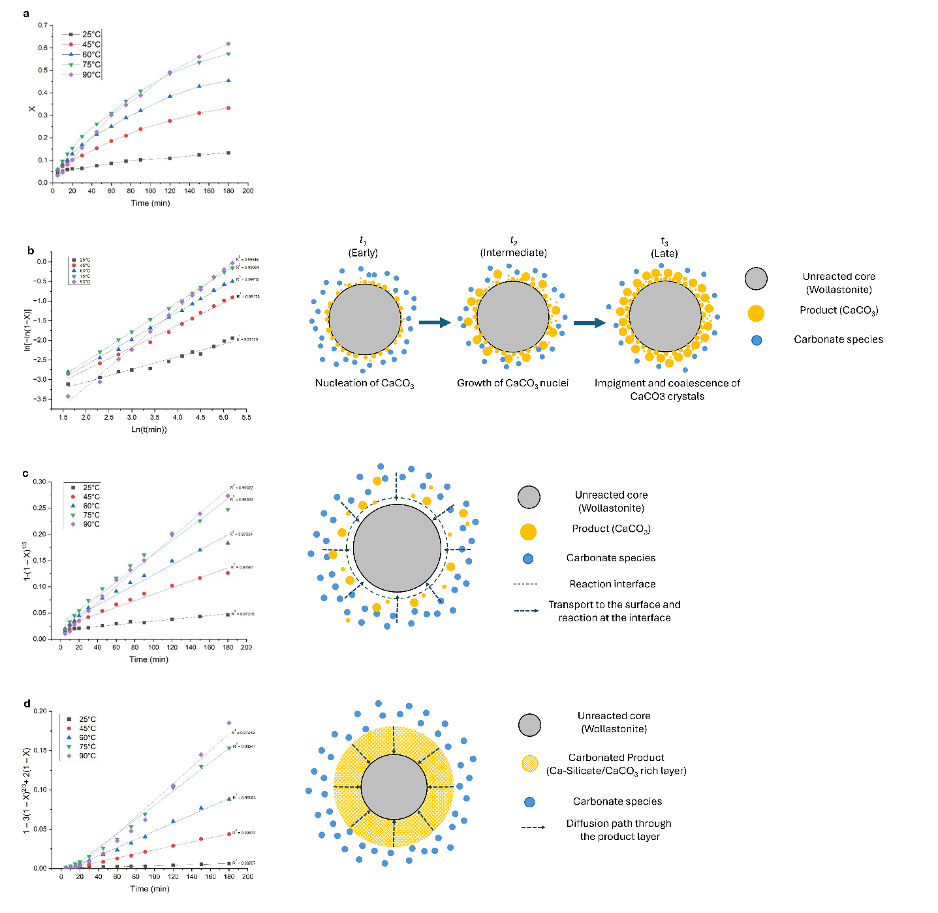

Figure 1 Experimental conversion profiles and corresponding linearized kinetic-model fits for wet wollastonite carbonation at 25°C, 45°C, 60°C, 75°C, and 90°C: (a) time-dependent conversion (X), (b)Avrami model, representing nucleation-and-growth-type transformation;(c) SCM surface chemical reaction control, representing interfacial reaction at the unreacted core, and (d) SCM diffusion-control model, representing transport through the developing product layer. The schematics on the right illustrate the corresponding conceptual carbonation pathways, including progressive carbonate formation, interface-controlled reaction, and diffusion through a product layer. Together, the figure links the experimental carbonation behavior with the kinetic-model interpretations used to describe the evolution of the reaction mechanism.

Arrhenius-type analysis & Apparent rate control and possible regime shift
To further assess the influence of temperature on wet wollastonite carbonation, Arrhenius analyses were conducted using kinetic parameters derived independently from the Avrami, SCM surface-reaction, and SCM diffusion models. The corresponding kinetic constants, regression statistics, and detailed activation-energy calculations are provided in the Supporting Information (Tables S5–S6).
The Arrhenius equation is widely employed to describe the temperature dependence of reaction rate constants [25–27]:
$$k=A·e^{(- \frac{E_{a}}{RT})}$$ | (9)
where k is the rate constant, A is the pre-exponential factor, E_{a} is the activation energy, R is the universal gas constant, and T is the absolute temperature in Kelvin. In its linearized form, the equation becomes:
$$Lnk=LnA-\frac{E_{a}}{RT}$$ | (10)
Therefore, plotting lnk against 1/T enables estimation of the activation energy from the slope of the fitted line.
The kinetic constants used in this analysis were obtained from the linearized forms of the applied models (TableS 4).
​ However, when n varies with temperature , the Avrami rate constant ka​, which has units of [time]^{−n}, cannot be directly treated as a conventional Arrhenius rate constant. Therefore, the corrected Avrami rate constant was calculated according to
k_{a(new)} = (k_{a})^{1/n} | (11)
This ensures that the resulting parameter has units of [time]⁻¹ and can be used in Arrhenius-type analysis. In the following sections, discussions referencing k_{a} always pertain to the new k_{a} [30].
Experimental conversion–time data confirmed that wet wollastonite carbonation proceeded more rapidly and extensively as temperature increased from 25°C to 90°C. To further assess this temperature dependence, Arrhenius-type analysis was performed using rate constants derived independently from the Avrami model, the surface-reaction-controlled shrinking-core model (SCM), and the diffusion-controlled SCM (Table S5). Because the linearized model fits showed different relative performances at individual temperatures, particularly at the temperature extremes (25°C and 90°C), using the rate constants from only one model across the entire temperature range would not adequately represent the evolution of the carbonation process. Therefore, the Arrhenius behavior of all three models was compared (Figure 2).
Interestingly, although the rate constants were obtained from different kinetic models and the single-temperature fits showed different model preferences, the Arrhenius plots displayed the same overall pattern. All three approaches revealed three comparable temperature intervals: 25°C –45°C (Stage I), 45°C –75°C (Stage II), and 75°C –90°C (Stage III). This consistency indicates that the observed stage-wise behavior is not an artifact of one specific model, but reflects a real change in the temperature dependence of the carbonation process. Therefore, wet wollastonite carbonation is better interpreted as a process in which the relative importance of dissolution, precipitation, and transport changes with temperature, rather than as a single invariant mechanism over the whole temperature range.
Stage I: Low-temperature hindered regime (25°C–45°C).
In the low-temperature interval, all three models yield relatively high apparent activation energies, indicating a strongly hindered regime in which carbonation is highly temperature-sensitive. Together with the low Avrami exponent (n = 0.32) and limited conversions, this suggests that insufficient wollastonite dissolution and slow release of reactive calcium species dominate the kinetic response. Therefore, the process is unlikely to be governed by a fully developed product-layer diffusion mechanism despite the superior fit of the diffusion-controlled SCM.
Stage II: Diffusion-influenced intermediate regime (45°C–75°C).
At intermediate temperatures, the apparent activation energies obtained from the diffusion-controlled SCM and the corrected Avrami model converge to similar values of approximately 40 kJ mol⁻¹–45 kJ mol⁻¹. In this interval, carbonation proceeds more effectively, while transport through the developing carbonate-silica layer increasingly influences the overall rate. This interpretation is consistent with the progressive product accumulation observed by XRD, DTG, SEM, and AFM, as well as the superior performance of the diffusion-controlled SCM.
Stage III: High-temperature mixed regime (75°C–90°C).
At higher temperatures, all three models converge to similar apparent activation energies of approximately 11 kJ mol⁻¹–12 kJ mol⁻¹. Although the surface-reaction-controlled SCM provides a better fit to the conversion profile at 90°C, the corresponding activation energies remain characteristic of systems in which transport effects are still significant. This apparent discrepancy suggests that the dominant transport limitation changes rather than disappears. While diffusion resistance at intermediate temperatures is primarily associated with transport through the carbonate-silica product layer, the reduced solubility of CO₂ at higher temperatures may increasingly influence gas dissolution and mass transfer in the liquid phase. Consequently, the behavior at 90°C is better interpreted as mixed control rather than a purely surface-reaction-controlled regime.
Furthermore, the decrease in Arrhenius slope from Stage I to Stage III indicates that, although temperature remains a major factor controlling carbonation, the kinetic benefit of further temperature increase is not constant across the investigated range. The strongest temperature sensitivity occurs at low temperatures, whereas the intermediate range (45°C –75°C) appears to represent the most effective operating window. At higher temperatures, the lower Arrhenius slope suggests diminishing kinetic gains, likely because transport-related limitations, including CO₂ dissolution and mass transfer in the liquid phase, become increasingly important. Therefore, beyond this intermediate interval, further temperature increases may provide limited additional benefit, implying that process intensification should focus on mitigating transport limitations and passivation effects rather than solely increasing temperature.
Accordingly, the calculated activation energies should be interpreted as regime-specific apparent parameters rather than intrinsic constants. This interpretation is further supported by the increase in the Avrami exponent from 0.32 at 25°C to approximately 0.99 at 90°C, indicating progressively less hindered transformation behavior with increasing temperature.
Importantly, Stage II (45°C –75°C) provides the most internally consistent activation-energy estimate. In this interval, the linearized model fitting identifies the diffusion-controlled SCM as the most suitable description, and the Arrhenius analysis based on diffusion-derived rate constants gives an apparent activation energy of approximately 39 kJ mol⁻¹–40 kJ mol⁻¹. This value is close to that obtained from the corrected Avrami rate constant (~45 kJ mol⁻¹), indicating that both model fitting and temperature-dependent analysis point to a diffusion-influenced regime in this range. Therefore, the most reliable and physically reportable activation energy in the present study is considered to be approximately 40–45 kJ mol⁻¹ for the intermediate temperature interval. In contrast, the activation energies obtained for Stage I and Stage III should be interpreted more cautiously, because the single-temperature model fitting and Arrhenius behavior are less consistent at the temperature extremes.
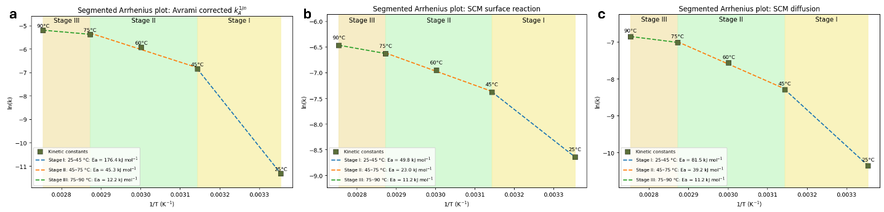
Figure 2: Segmented Arrhenius-type plots of kinetic parameters derived from the Avrami and SCM analyses for wet wollastonite carbonation. (a) Corrected Avrami rate constant ka^{1/2}, (b) SCM surface-reaction rate constant, and (c) SCM diffusion rate constant plotted as ln(k) versus 1/T. The shaded regions indicate the proposed temperature intervals: Stage I (25–45)°C, Stage II (45–75)°C, and Stage III (75–90)°C, used to evaluate regime-specific apparent activation energies.

Particle-size effect at one temperature
To further assess the kinetic behavior of wet wollastonite carbonation, the influence of particle size was investigated at 90°C, which yielded the highest conversion in the temperature-dependent experiments. The particle-size effect was examined by comparing a ground fine sample with a non-ground coarse sample under otherwise identical carbonation conditions. This comparison was intended to clarify how particle size reduction affects both the reaction rate and the apparent kinetic behavior of wollastonite carbonation[21].
The conversion–time profiles (Figure 3 - a) clearly show that the fine fraction carbonated more rapidly than the coarse fraction over the entire reaction period. Although both samples exhibited the same general trend of increasing conversion with time, the fine sample consistently showed higher conversion values and reached a greater final conversion after 180 min. This demonstrates that particle size reduction significantly enhances the carbonation kinetics of wollastonite. The improved performance of the fine fraction can be attributed mainly to its larger accessible surface area. BET analysis showed that the fine sample had a specific surface area of 4.67 m² g⁻¹, compared with 1.49 m² g⁻¹ for the coarse fraction. This higher surface area provides a greater density of reactive sites and promotes more effective contact between the mineral surface and the reactive aqueous phase. In addition, the smaller particle size likely facilitates faster dissolution of calcium-bearing species and improves the accessibility of the reacting interface.
The difference between the fine and coarse samples becomes more pronounced with reaction time, indicating that the effect of particle size is not limited to the initial stage of carbonation. Rather, particle size reduction also supports sustained reaction progress at longer times. Therefore, grinding appears to improve both the initial reactivity and the overall efficiency of wollastonite carbonation under the selected experimental conditions.
To further interpret the particle-size-dependent behavior, the experimental data were analyzed using the linearized Avrami model together with the shrinking-core models for chemical reaction control and diffusion control (Figure 3 – b,c,d). The Avrami model provided a good overall description of carbonation behavior for both fine and coarse wollastonite, with linearized plots showing clear linearity in both cases. This indicates that nucleation and growth of the carbonate product remain important features of the carbonation pathway regardless of particle size.
A more mechanistic distinction emerges from the shrinking-core model analysis. The chemical-reaction-controlled expression provided the most suitable description for both particle-size fractions, with linearized SCM chemical reaction plots (Figure 3- c) showing stronger agreement with experimental data than diffusion-controlled plots. This suggests that carbonation is controlled primarily by the interfacial reaction at the unreacted wollastonite surface rather than by diffusion through a product layer. The fine sample exhibited a steeper slope, indicating a higher apparent reaction rate constant, confirming that particle size reduction enhances the rate of the same governing mechanism rather than introducing a different one. The finer fraction carbonates more rapidly because grinding exposes more reactive surface and improves accessibility of active sites; the coarser fraction remains slower due to limited interfacial reaction rates.
Residual analysis supports this interpretation(FigureS1). Avrami model residuals remained relatively small for both samples, though the model is less diagnostic of the specific rate-limiting step. SCM chemical reaction residuals were more consistently distributed around zero than those of the diffusion-controlled model, confirming that the surface-reaction-controlled formulation better captures the particle-size-dependent kinetic response.
XRD analysis (Figure 4) confirmed progressive conversion of wollastonite and formation of calcite as the primary carbonate product, while also revealing distinct differences in carbonate crystal (Calcite) development between the two fractions. The coarse sample exhibited larger calcite crystallites, demonstrating that feed particle size affects both conversion degree and crystallization behavior. Complementary SEM and thermal analysis (Figure 5,Figure 11) support this conclusion: calcite formed on the coarse feed displayed a more pronounced rhombohedral morphology, and slightly higher T(DTG_{max)}) values indicate increased thermal stability of the carbonate phase, consistent with larger crystallite sizes determined by XRD [30]. A likely explanation is that the finer material, due to its higher specific surface area, provides more nucleation sites, resulting in more distributed precipitation of smaller carbonate domains, whereas the coarser feed favors growth of fewer but larger calcite crystals.
The influence of particle size is primarily quantitative rather than mechanistic. Particle size reduction enhanced carbonation rate and final conversion, but the dominant apparent kinetic regime remained unchanged. In contrast, temperature affected both the reaction rate and the apparent mechanistic behavior identified by model comparison, suggesting that temperature exerts a stronger influence than particle size on the overall kinetics of wet wollastonite carbonation.
In summary, reducing wollastonite particle size significantly improves carbonation performance at 90°C. The fine fraction achieved higher conversion throughout the reaction period, while kinetic model analysis indicates similar apparent kinetic behavior for both particle-size fractions, with a stronger contribution from surface-related processes at 90°C. XRD, SEM, and T(DTGmax) results further show that particle size influences the crystallization characteristics of the product phase, with the coarse sample favoring larger calcite crystals. The beneficial effect of particle size reduction is therefore best understood as an acceleration of the existing carbonation pathway rather than a shift to a different mechanistic regime.

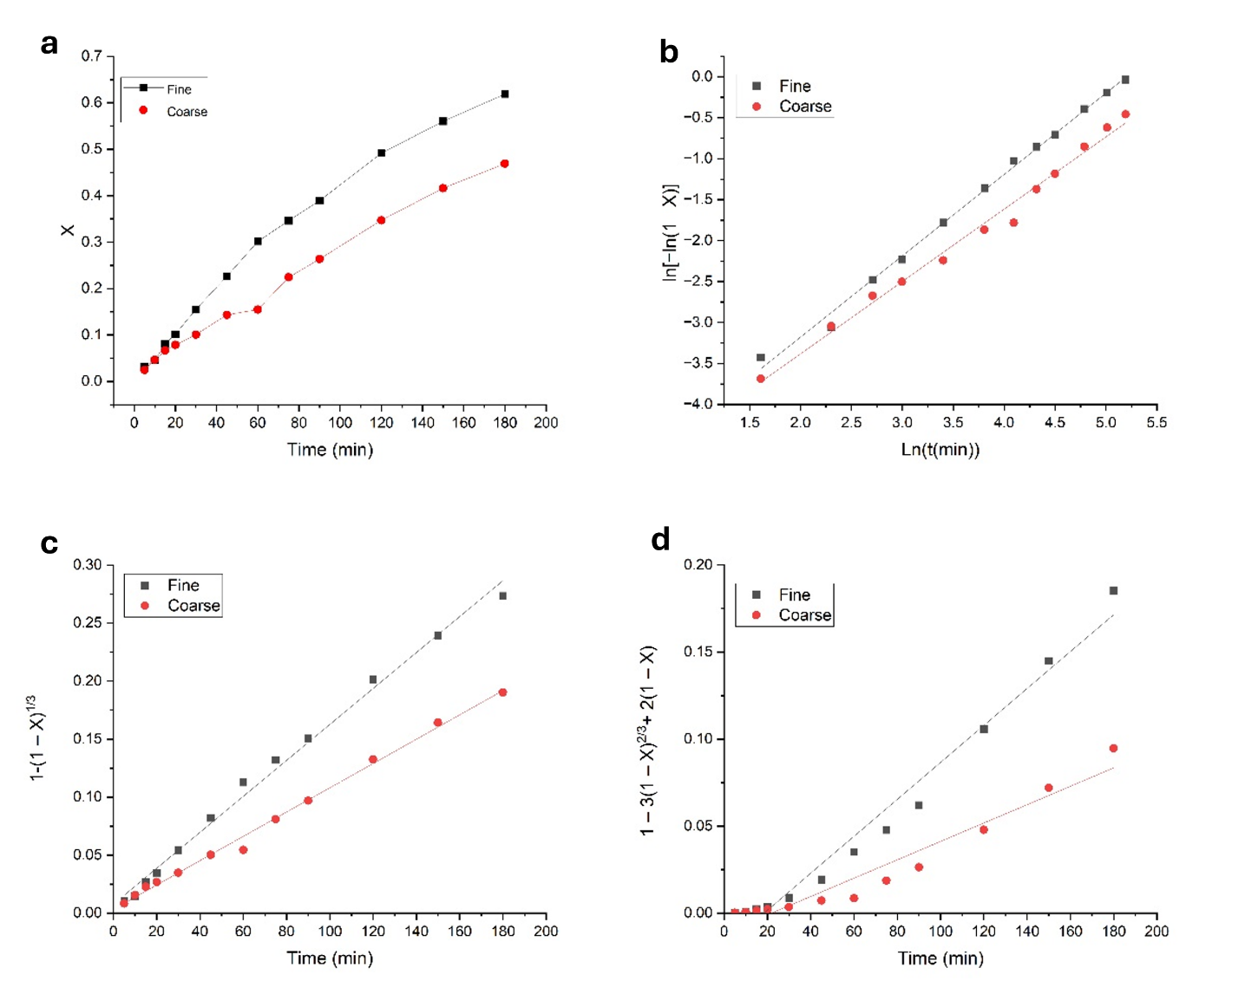
Figure 3: Comparison of the experimental conversion behavior and linearized kinetic-model fits for fine and coarse wollastonite during wet carbonation at 90 °C: (a) conversion (X) as a function of time, (b) Avrami model, (c) SCM surface chemical reaction control, and (d) SCM diffusion control. These plots provide the basis for assessing the influence of particle size on both carbonation progress and the apparent kinetic regime.

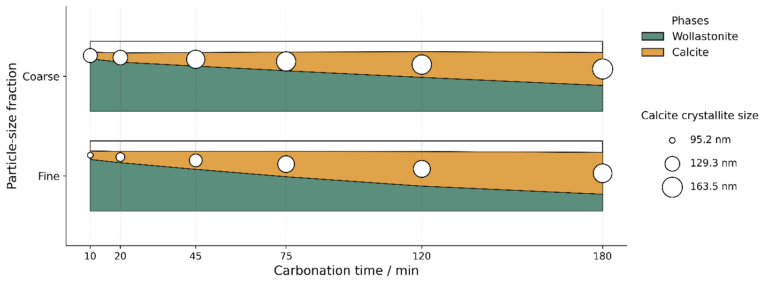

Figure 4: Time-dependent phase evolution and calcite crystallite-size development for fine and coarse wollastonite during wet carbonation at 90°C observed with XRD, illustrating the faster wollastonite-to-calcite transformation of the fine fraction and the larger calcite crystallites formed in the coarse fraction. The colored fields show the relative fractions of wollastonite and calcite as a function of carbonation time, while the circles’ size represents the corresponding calcite crystallite size

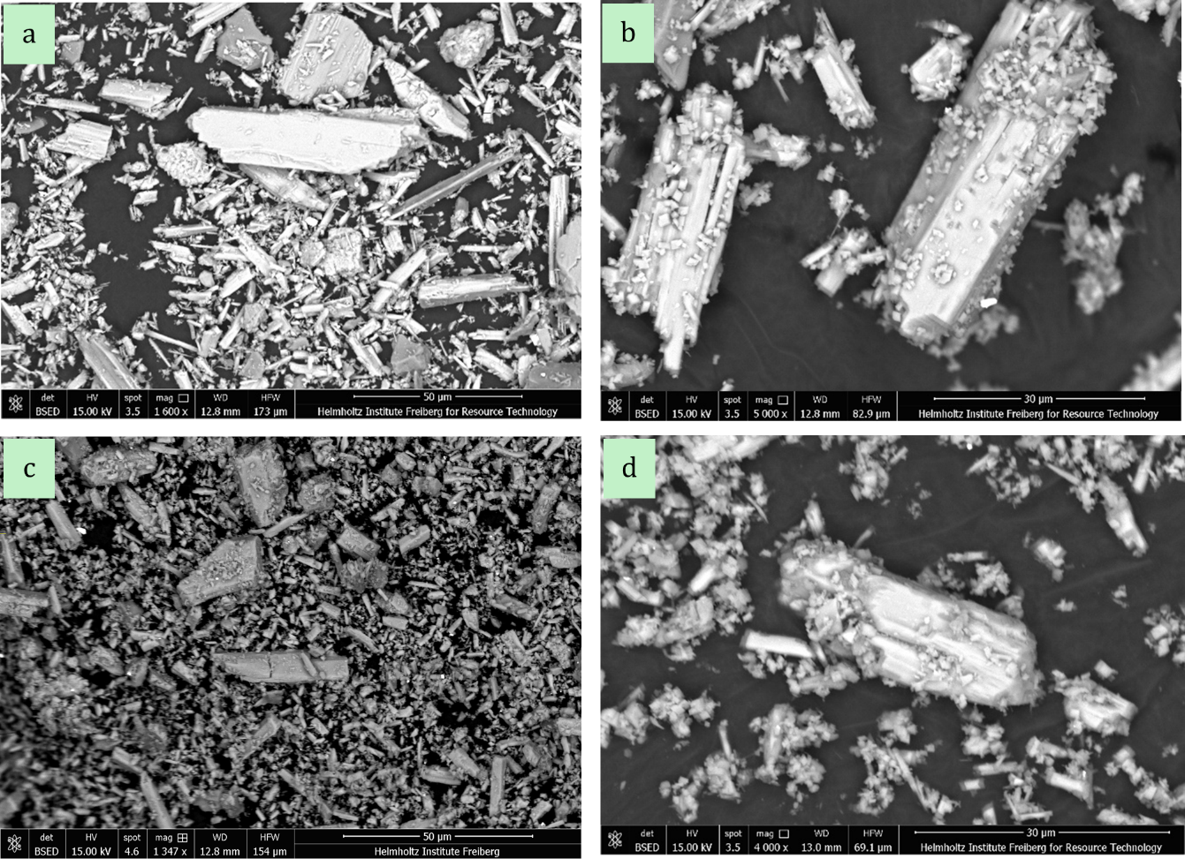

Figure 5: SEM backscattered images of the wollastonite feed and corresponding carbonated products for the two particle-size fractions: (a) coarse feed, (b) carbonated coarse feed, (c) fine feed, and (d) carbonated fine feed. The images illustrate the morphology of the initial feed particles and the development of the precipitated carbonate phase after carbonation, highlighting the influence of feed particle size on product morphology and crystal development.

Structural, thermal, and morphological observations of temperature-dependent carbonation evolution
Time-resolved XRD analysis (Figure 6) confirmed progressive carbonation under all investigated conditions, with wollastonite content decreasing and calcite content increasing with reaction time, supporting the TGA-based conversion trends. The extent of phase evolution was strongly temperature-dependent: only minor changes occurred at 25°C, moderate transformation at 45°C, and substantially greater calcite formation at 60°C, 75°C, and especially 90°C.
Calcite crystallite size increased with both reaction time and temperature, consistent with previous findings for carbonation systems [31–34]. This structural maturation provides a physical explanation for the shift in the Avrami exponent n: larger crystallites at 90°C correspond to the transition toward n ≈ 0.99, indicative of less-constrained interface-controlled growth, while smaller crystallites at lower temperatures are consistent with the restricted growth environment reflected by the sub-diffusion exponent n = 0.32 [23,38]. DTG results (Figure 11) further support this interpretation, with (T(DTG_{max})) shifting to higher values with increasing reaction time and temperature, indicating development of a more thermally stable and structurally ordered carbonate phase, consistent with earlier carbonation investigations [31,35].
SEM analysis (Figure 7) establishes a connection between kinetic regimes and physical product development. At 25°C, minimal surface modification and sparse carbonate precipitation are observed, with wollastonite particles largely retaining their original morphology, consistent with the low n value and high Ea. At 45°C and 60°C, carbonate coverage becomes more pronounced though crystal development remains moderate, consistent with the diffusion-influenced intermediate regime (n = 0.57–0.67). At 75°C and 90°C, extensive surface precipitation and well-defined calcite morphologies are observed.
Collectively, XRD, DTG, and SEM results demonstrate that increasing temperature enhances both the extent of wollastonite-to-calcite transformation and the degree of structural development, with the progression from sparse precipitation to well-defined crystalline growth closely paralleling the increase in n from 0.32 to 0.99, confirming a thermally driven transition from a diffusion-limited to a more rapid interface-influenced growth regime.
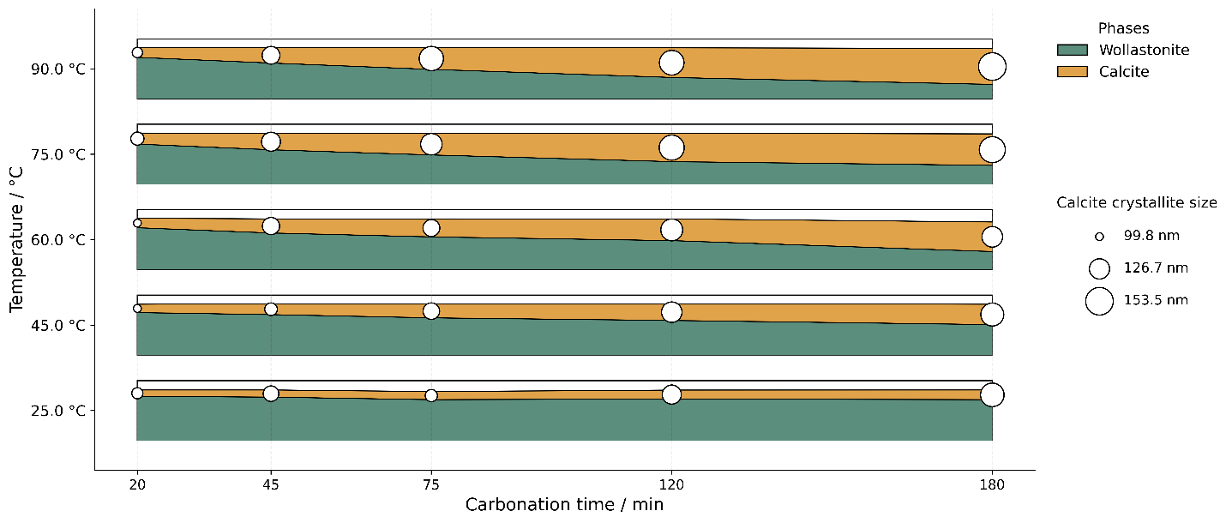
Figure 6: Combined representation of quantitative phase evolution and calcite crystallite-size development during wet wollastonite carbonation at different temperatures. The colored fields show the relative fractions of wollastonite and calcite as a function of carbonation time, while the circles’ size represents the corresponding calcite crystallite size.

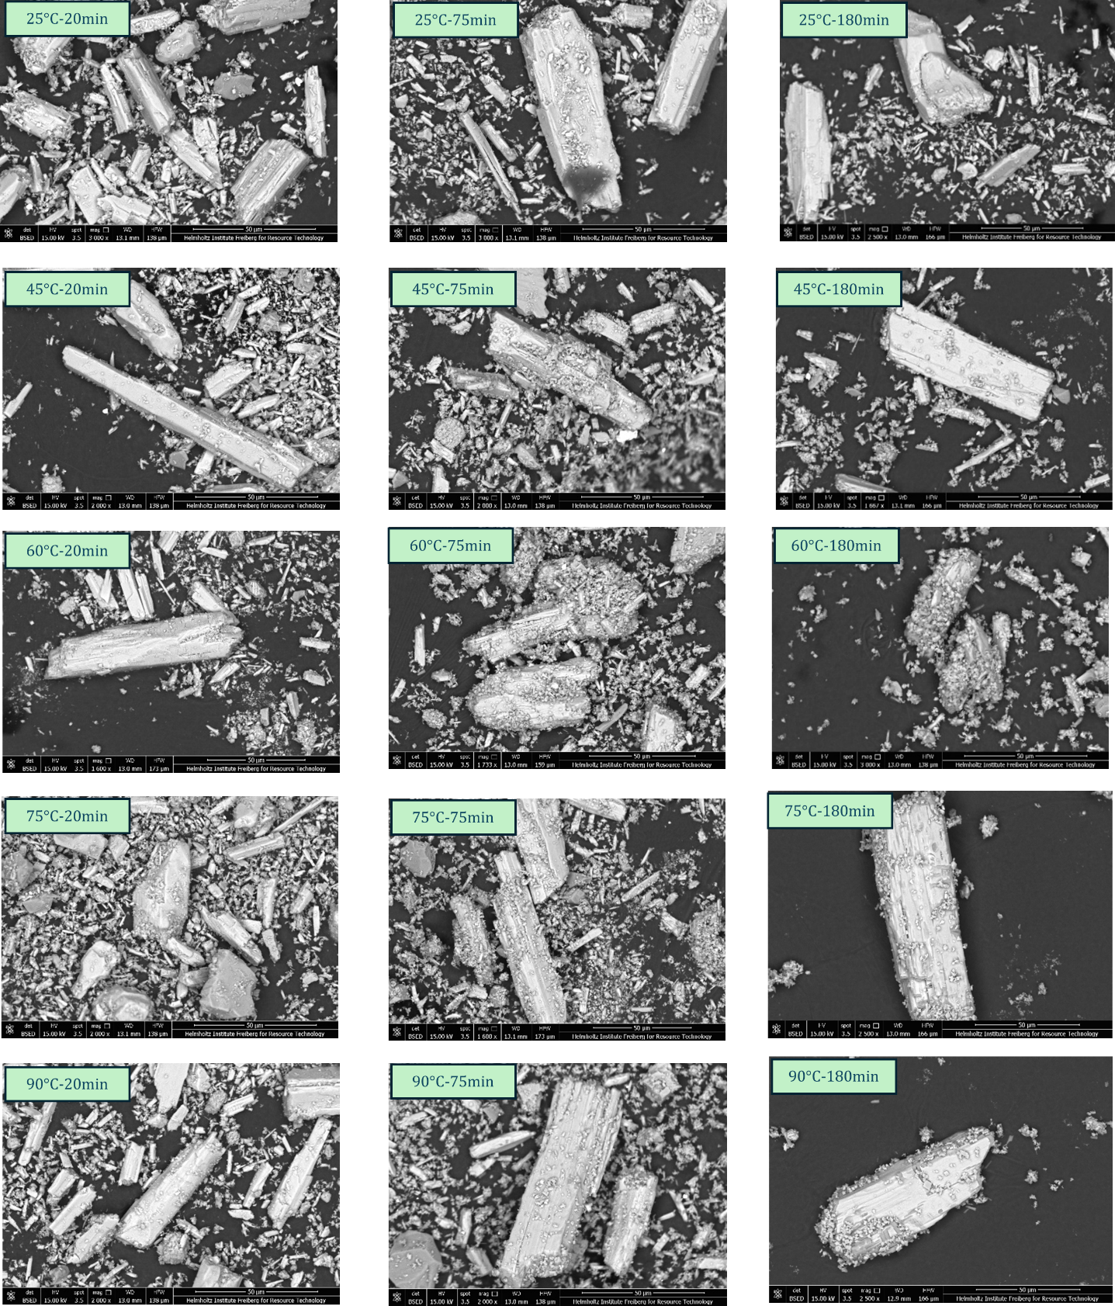

Figure 7: SEM micrographs of wollastonite carbonated under different temperatures and reaction times, illustrating the progressive evolution of carbonate morphology during wet carbonation. Images are shown for 25°C, 45°C, 60°C, 75°C, and 90°C at 20 min, 75 min, and 180 min, highlighting the combined influence of temperature and time on surface coverage, carbonate precipitation, and crystal development

AFM investigation of carbonation-induced surface evolution at 60°C and 90°C
Optical microscopy (Figure 8 (a-d)) and atomic force microscopy (AFM) (Figure 8 (e-j)) were employed to analyze embedded samples carbonated at 60°C and 90°C, representing distinct kinetic regimes. Optical microscopy revealed pronounced color and contrast variations and cleavage-like and locally fractured features, more prominent in carbonated samples than in the polished unreacted feed, confirming that carbonation modifies the wollastonite surface and affects not only surface precipitation but also the structural integrity of the original mineral particles. Comparison with SEM observations (Figure 5) further supports this interpretation.
These observations can be interpreted through two complementary and potentially coexisting hypotheses. The first attributes the altered optical contrast and surface appearance to formation of a heterogeneous passivating layer comprising silica-rich gel-like phases or precipitated calcite, which progressively reduces accessibility of the reacting interface and contributes to diffusion-related limitations identified in the kinetic analysis. The second, not mutually exclusive, interpretation is that subsurface carbonation leads to cleavage, whereby carbonic acid penetrates below the original surface and promotes calcite formation within the particle. Because calcite has a lower density than wollastonite [31], local volume increase upon replacement may generate subsurface stress, leading to uplift, bending, and disruption of the reacted layer, consistent with the cleavage-like and fractured features observed by SEM and AFM.
The available microscopy observations do not permit an unambiguous distinction between these mechanisms, and both likely contribute to the observed morphology. Nevertheless, each is consistent with the broader kinetic and structural results, confirming that surface evolution plays a significant role in controlling the carbonation pathway. AFM was subsequently used to compare topography and phase contrast of polished and carbonated embedded samples.
Atomic force microscopy (AFM) measurements provided quantitative results of carbonation-induced surface modification as summarized in Table 1. In comparison to the polished reference, both carbonated samples exhibited a marked increase in surface roughness (root mean square R_{q}, arithmetic average R_{a}, mean roughness depth R_{z}), with all topographic parameters increasing after carbonation and reaching their highest values in the 90°C sample. Notably, the substantial increases in R_{a}, R_{q}, and R_{z} indicate that carbonation results in a more heterogeneous and topographically complex surface (Table 1). This trend aligns with observations from optical microscopy, scanning electron microscopy (SEM), and kinetic analyses, and suggests that elevated temperature facilitates more extensive modification of the near-surface region. The phase shift signal of the vibrating cantilever in dynamic tapping mode is processed in a similar manner like the topographic signal by means of determining mean values φ_{q}, φ_{a} and φ_{z}, respectively [36,37]. With an increasing degree of carbonation, those values are decreasing. This can be contributed to the formation of carbonation product layers on the wollastonite surface making it chemically more homogeneous, especially with respect to the silica layer as a second product of wollastonite carbonation next to calcium carbonate. Nonetheless, these finding need more attention in future investigations as no references are known to the authors to compare with.
Table 1: AFM topography (R_{a}, R_{q}, R_{z}) and phase (φ_{q}, φ_{a}, φ_{z}) parameters (geometric mean g, arithmetic mean a and mean depth z) for the polished reference and the carbonated samples at 60°C and 90°C, summarizing the quantitative evolution of surface roughness and phase contrast variations after carbonation.
Topography values
Conditions | R_{q} in nm | R_{a} in nm | R_{z} in nm
Polished | 1.6 ± 0.3 | 1.2 ± 0.3 | 21.3 ± 7.8
Carbonated 60°C | 7.9 ± 4.5 | 3.3 ± 1.3 | 146.5 ± 98.0
Carbonated 90°C | 12.2 ± 7.0 | 6.5 ± 3.6 | 184.4 ± 92.0
Phase values
Conditions | φ_{q} in ° | φ_{a} in ° | φ_{z} in °
Polished | 4.3 ± 2 | 3.2 ± 1.5 | 50.4 ± 18.0
Carbonated 60°C | 4.2 ± 1.3 | 3.2 ± 1.0 | 57.1 ± 21.4
Carbonated 90°C | 1.6 ± 0.6 | 0.9 ± 0.4 | 36.4 ± 12.6

AFM imaging (Figure 8 (a-j)) provided visual evidence of carbonation-induced surface evolution. Compared to the polished reference, carbonated samples exhibited significantly increased roughness and more heterogeneous surface features, consistent with the topographic parameters in Table 1. Scratches visible on the polished surface appeared partially filled or overgrown after carbonation, indicating that reaction products accumulate on flat regions and within pre-existing surface depressions. This supports the kinetic interpretation that product buildup progressively reduces surface accessibility and contributes to diffusion-related limitations. Bright topographic features, interpreted as carbonate-rich precipitates, were larger and more developed in the 90°C sample than in the 60°C sample, consistent with the higher carbonation degree and more advanced product development identified by other characterization methods.
Phase images differed from corresponding topography maps, indicating that carbonation influences not only surface height but also local chemical properties, likely reflecting compositional heterogeneity within the reacted layer, potentially comprising calcite-rich regions and silica-rich altered material. Although AFM phase contrast alone cannot definitively identify composition, the observed differences are consistent with XRD, SEM, and the proposed passivation behavior. The higher phase contrast of polishing scratches on the fresh surface (Figure 8 h) may reflect elevated surface energies of scratched regions, which are subsequently reduced by carbonation product layers. The origin of the brighter spots observed on the 60°C (Figure 8 i) and 90°C (Figure 8 j ) carbonated substrates require further investigation.
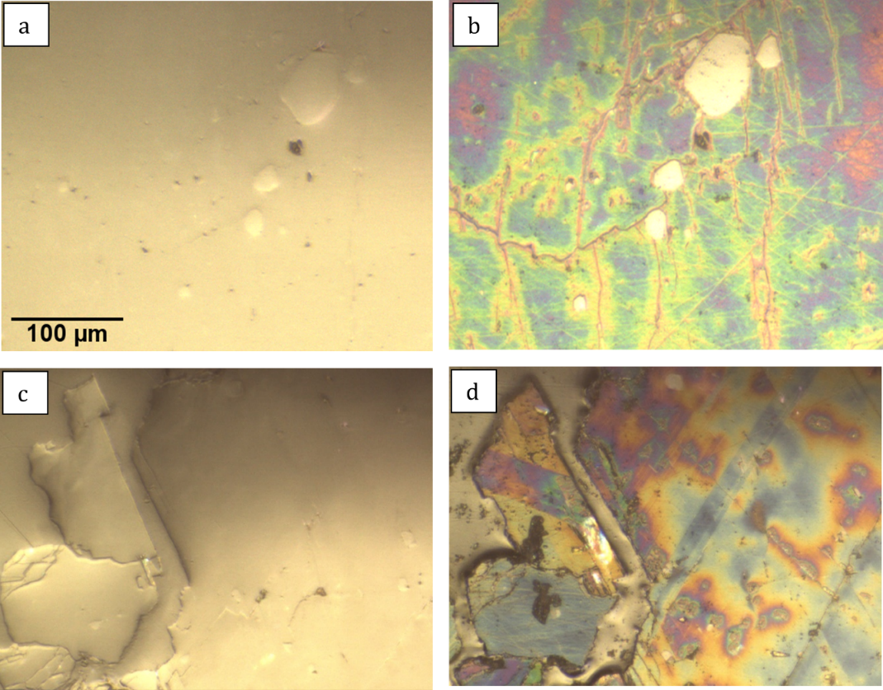
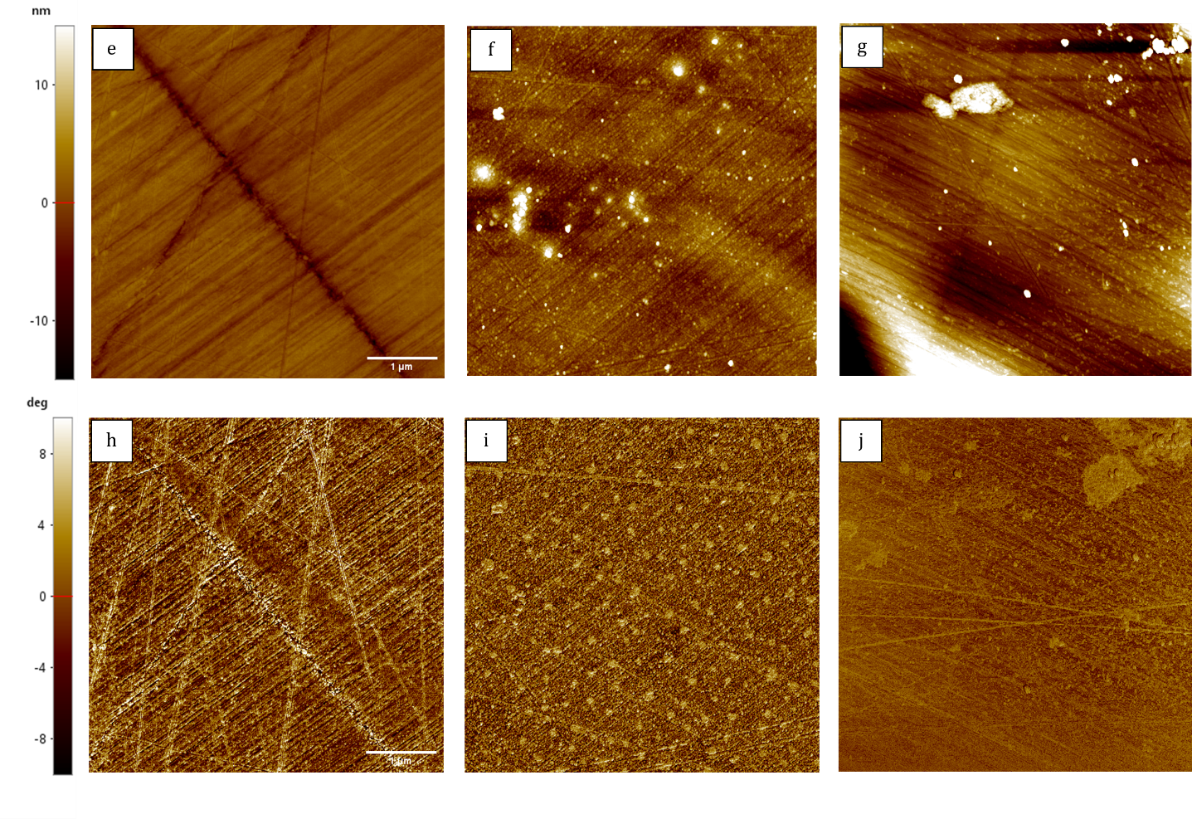
Figure 8: Optical microscopy and AFM images of embedded wollastonite samples before and after carbonation at 60°C and 9 °C. Panels (a–d) show optical microscopic images of the polished and carbonated samples, where the colorful appearance of the carbonated regions arises from white-light interference and reflects carbonation-induced surface alteration. Panels (e–g) present AFM topography images of the polished reference and the carbonated surfaces at 60°C and 90°C, while panels (h–j) show the corresponding AFM phase images. The combined optical and AFM observations reveal clear carbonation-induced changes in surface appearance, topography, and local surface heterogeneity.

Conclusion

Wet wollastonite carbonation under mild conditions was investigated using a time-resolved approach over 25°C –90°C, together with a particle-size comparison at 90°C. Carbonation proved strongly temperature dependent, with both reaction rate and final conversion increasing substantially with temperature.
Kinetic analysis showed that the process cannot be described by a single invariant mechanism across the full temperature range. The Avrami model fit the data well at all temperatures, indicating that nucleation-and-growth-type transformation remains relevant throughout. However, changes in the Avrami exponent and the Arrhenius behavior obtained from different kinetic models revealed that the relative contributions of dissolution, precipitation, and transport processes vary with temperature. Despite differences in the single-temperature model fits, the Arrhenius plots derived from the Avrami and SCM rate constants exhibited remarkably similar trends and consistently identified three temperature intervals corresponding to a strongly hindered low-temperature regime, a diffusion-influenced intermediate regime, and a high-temperature mixed-control regime. The intermediate temperature range (45°C –75°C) showed the most internally consistent behavior, yielding apparent activation energies of approximately 40 mol⁻¹–45 kJ mol⁻¹, characteristic of diffusion-influenced control.
Characterization results were consistent with the kinetic interpretation. XRD showed progressive wollastonite depletion and calcite formation, with crystallite size increasing with time and temperature. DTG suggested greater carbonate thermal stability at higher temperatures, and SEM showed increasingly developed calcite morphology. Optical microscopy and AFM on embedded substrates carbonated at 60°C and 90°C confirmed surface modification, with changes in topography and phase response supporting formation of a heterogeneous altered layer associated with carbonate precipitation and/or silica-rich surface products. The Avrami exponent evolution, from ~0.32 at 25°C to ~0.99 at 90°C, further supports progressively less hindered and more structurally developed carbonation with increasing temperature.
The particle-size study at 90°C confirmed that the fine fraction carbonated more rapidly and reached higher conversion, reflecting the beneficial effect of increased surface area. However, both fractions exhibited similar apparent kinetic behavior, indicating that particle size primarily influences reaction rate and conversion degree rather than changing the dominant kinetic response. This is consistent with the Arrhenius interpretation for the high-temperature range, where the rate behavior appears to be increasingly affected by CO₂ dissolution and gas–liquid transport limitations rather than by solid dissolution or precipitation alone. The coarse fraction nonetheless promoted the formation of larger and more distinct calcite crystals, indicating that feed particle size also influences the crystallization pathway.
Overall, temperature exerted the strongest influence on wet wollastonite carbonation, affecting conversion, apparent rate behavior, and product development. These findings provide an integrated kinetic and microstructural framework for understanding and optimizing wet carbonation of calcium silicates. Nevertheless, the nature, evolution, and limiting role of the passivating product layer require further investigation, as improved understanding will be essential for identifying strategies to mitigate passivation, enhance kinetics, and clarify how evolving process variables influence the reactivity and performance of the resulting carbonated materials, particularly regarding their potential use as supplementary cementitious materials.

Materials and methods

Raw material
Natural wollastonite supplied by Töpfereibedarf Lehrer GesmbH (Austria) was used as the starting material in this study. The material was used as received, without further purification; only grinding was applied where required. Prior to carbonation, the feedstock was characterized to define its initial chemical, mineralogical, and physical properties. X-ray fluorescence (XRF) confirmed a Ca–Si composition consistent with natural wollastonite, with CaO and SiO₂ contents of 42.9 and 51.8 % (m/m), respectively. X-ray diffraction (XRD) identified wollastonite as the predominant crystalline phase, with minor calcite also detected. Laser-diffraction analysis showed that the ground sample was finer than the non-ground sample, with d_{90,3} ​ values of 24 μm and 42.7 μm, respectively. Brunauer-Emmett-Teller (BET) and helium pycnometry gave an initial specific surface area of 4.67 m²/g and a skeletal density of 2.895 g/cm³ [38] . Detailed composition, phase, particle-size data, and characterization settings are provided in the Supporting Information (TableS 1,TableS 2,TableS 3).

Wet Carbonation Experimental Procedure
The carbonation experiments were carried out at atmospheric pressure in a batch reflux setup (Figure 9).
Prior to carbonation, wollastonite was ground in a disc mill (Retsch RS 200, Germany) for 10 minutes unless otherwise specified. Once the reactor reached the target temperature and the CO₂ flow stabilized, the solid was introduced according to the selected solid-to-liquid ratio. Carbonation experiments were conducted under otherwise identical conditions (S/L = 10%, Rotational speed = 900 rpm, CO₂ flow rate = 700 ml min⁻¹), with temperature varied between 25°C and 90°C for kinetic analysis. To assess the effect of particle size, additional experiments at 90°C compared a finely ground sample with a coarse, non-ground sample. Following the reaction, the slurry was dried at 105°C for 12 hours before further analysis.
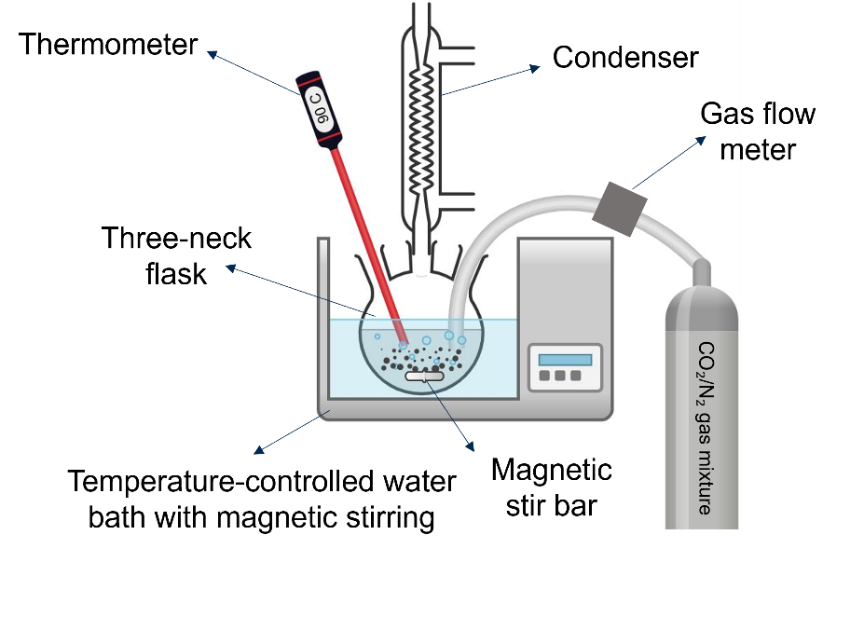
Figure 9 Schematic of the atmospheric-pressure batch reactor used for wet wollastonite carbonation, comprising a three-necked flask, condenser, thermometer, magnetic stirring, temperature-controlled water bath, and regulated CO₂ gas inlet.

Characterization Methods
The chemical composition of the feed material was determined by wavelength-dispersive X-ray fluorescence (WD-XRF) using a PANalytical AxiosmAX spectrometer (Rh anode). Crystalline phases before and after carbonation were identified by powder XRD using a PANalytical Empyrean diffractometer (Co radiation), with qualitative phase identification performed in PANalytical HighScore (3.0.4) using the ICDD PDF-5+ (2025) database, and quantitative phase analysis obtained by Rietveld refinement in Profex (5.1.0)[39]. CO₂ uptake was quantified by Thermogravimetric analysis (TGA) using a NETZSCH TG 309 Libra Classic under nitrogen atmosphere at 20 K min⁻¹ up to 1000°C. Particle size distribution was measured by laser diffraction (Sympatec HELOS), and specific surface area by N₂ adsorption (BET method, Micromeritics Gemini VII 2390t). Microstructural and morphological changes were examined by Scanning Electron Microscopy (SEM), with elemental distributions analyzed by energy-dispersive X-ray spectroscopy EDX using a FEI Quanta 650 FEG instrument equipped with Bruker Quantax X-Flash 5030 detectors. For Atomic Force Microscopy (AFM) characterization, two larger pieces of natural wollastonite (~15 mm) were embedded in a 20 mm epoxy mount, ground, and polished (0.2 µm diamond slurry), then characterized before and after carbonation in the same setup Figure 9. using a Park Systems NX 12 in tapping mode for height and phase mapping, with Tap300Al-G cantilevers (BudgetSensors, Bulgaria; nominal resonance frequency 300 kHz).

Kinetic study design
To investigate the temperature dependence of wet wollastonite carbonation kinetics, experiments were conducted at 25°C, 45°C, 60°C, 75°C, and 90°C while keeping the solid-to-liquid ratio, stirring speed, CO₂ flow rate, and feed particle size constant.
At each temperature, reaction progress was monitored at (5, 10, 15, 20, 30, 45, 60, 75, 90, 120, 150, and 180) minutes. To maintain constant solid–liquid ratios, hydrodynamic conditions, and gas–liquid interactions, a separate batch run was performed for each time point, giving 12 independent runs per temperature and avoiding artifacts associated with repeated sampling.
To assess the influence of particle size, additional experiments were conducted at 90°C by comparing a finely ground wollastonite sample with a coarse, non-ground sample under otherwise identical conditions.
All datasets were evaluated using the linearized form of the Avrami model, the shrinking-core model with surface chemical reaction control, and the shrinking-core model with diffusion control. The fitted kinetic parameters were then used in Arrhenius-type analysis to estimate the apparent activation energies of the dominant carbonation regimes.

CO₂ uptake and conversion determination
The theoretical CO₂ uptake of wollastonite was estimated from the bulk chemical composition measured by XRF (TableS 1), assuming carbonation of the reactive Ca- and Mg-bearing components. Based on the natural carbonate content of the feed measured by TGA, the theoretical CO₂ uptake was calculated as [31]:
Theoretical CO₂ Uptake (%) = (0.78·Z + 1.1·Y) *100 % - Natural CO₂ (%) | (10)
where Z and Y are the mass fractions of CaO and MgO in the feed, respectively. Based on the feed composition and the corresponding correction for native carbonate content, the theoretical CO₂ uptake of the wollastonite used in this study was calculated to be 32.3 % (m/m).
The experimental CO₂ uptake was determined by thermogravimetric analysis from the carbonate-related mass loss in the temperature range of 500°C - 900°C, corresponding mainly to CO₂ release from carbonate decomposition. To exclude the contribution of pre-existing carbonates in the raw material, the normalized CO₂ uptake was calculated as the difference between the carbonated sample and the feed (this method was used and described before in [31,40]):
CO₂ Uptake % = ($\frac{∆m_{Carb,500-900} }{100-∆m_{Carb,30-1000}}-\frac{∆m_{Feed,500-900}}{100-∆m_{Feed,30-1000}})×\frac{100-∆m_{Feed,30-1000}}{100}$ | (11)
$\text{∆}{\text{m}}_{\text{s,500-900}}\text{=}{\text{m}}_{\text{s,500 °C}} \text{- }{\text{m}}_{\text{s,900 °C}}$ | (12)
$$\text{∆}{\text{m}}_{\text{s,30-1000}}\text{=}{\text{m}}_{\text{s,30 °C }}\text{-}{\text{ m}}_{\text{s,1000 °C}}$$ | (13)
where $∆m_{s,500-900}$ (s denotes the sample state) represents the mass loss associated with carbonate decomposition and $∆m_{s,30-1000}$ is the total normalized mass loss used for correction.

Acknowledgements
This work is part of the CO₂Valorize project, which has received funding from the European Union’s Horizon Europe research and innovation program under the Marie Skłodowska-Curie Grant Agreement No. 101073547. The authors would like to thank Dr. Bradley Martin Guy and Ava Holowenko for assistance with SEM-EDX measurements at HZDR, Helmholtz Institute Freiberg for Resource Technology (HIF); and Erik Löwer from Freiberg University of Mining and Technology for assistance with BET analyses.

References
[1] A. Sanna, M. Uibu, G. Caramanna, R. Kuusik, M.M. Maroto-Valer, A review of mineral carbonation technologies to sequester CO ₂, Chem. Soc. Rev. 43 (2014) 8049–8080. https://doi.org/10.1039/C4CS00035H.
[2] S.J. Davis, N.S. Lewis, M. Shaner, S. Aggarwal, D. Arent, I.L. Azevedo, S.M. Benson, T. Bradley, J. Brouwer, Y.-M. Chiang, C.T.M. Clack, A. Cohen, S. Doig, J. Edmonds, P. Fennell, C.B. Field, B. Hannegan, B.-M. Hodge, M.I. Hoffert, E. Ingersoll, P. Jaramillo, K.S. Lackner, K.J. Mach, M. Mastrandrea, J. Ogden, P.F. Peterson, D.L. Sanchez, D. Sperling, J. Stagner, J.E. Trancik, C.-J. Yang, K. Caldeira, Net-zero emissions energy systems, Science 360 (2018) eaas9793. https://doi.org/10.1126/science.aas9793.
[3] A. Ismailov, N. Merilaita, E. Levänen, Accelerated Carbonation of High-Calcite Wollastonite Tailings, Minerals 14 (2024) 415. https://doi.org/10.3390/min14040415.
[4] S.-Y. Pan, T.-C. Chung, C.-C. Ho, C.-J. Hou, Y.-H. Chen, P.-C. Chiang, CO2 Mineralization and Utilization using Steel Slag for Establishing a Waste-to-Resource Supply Chain, Sci Rep 7 (2017) 17227. https://doi.org/10.1038/s41598-017-17648-9.
[5] F. Wang, D. Dreisinger, M. Jarvis, T. Hitchins, Kinetics and mechanism of mineral carbonation of olivine for CO2 sequestration, Minerals Engineering 131 (2019) 185–197. https://doi.org/10.1016/j.mineng.2018.11.024.
[6] H. Ostovari, L. Müller, J. Skocek, A. Bardow, From Unavoidable CO ₂ Source to CO ₂ Sink? A Cement Industry Based on CO ₂ Mineralization, Environ. Sci. Technol. 55 (2021) 5212–5223. https://doi.org/10.1021/acs.est.0c07599.
[7] A. Bărbulescu, K. Hosen, Cement Industry Pollution and Its Impact on the Environment and Population Health: A Review, Toxics 13 (2025) 587. https://doi.org/10.3390/toxics13070587.
[8] M. Hanifa, R. Agarwal, U. Sharma, P.C. Thapliyal, L.P. Singh, A review on CO2 capture and sequestration in the construction industry: Emerging approaches and commercialised technologies, Journal of CO2 Utilization 67 (2023) 102292. https://doi.org/10.1016/j.jcou.2022.102292.
[9] S. Srivastava, M. Cerutti, H. Nguyen, V. Carvelli, P. Kinnunen, M. Illikainen, Carbonated steel slags as supplementary cementitious materials: Reaction kinetics and phase evolution, Cement and Concrete Composites 142 (2023) 105213. https://doi.org/10.1016/j.cemconcomp.2023.105213.
[10] S.J. Gerdemann, W.K. O’Connor, D.C. Dahlin, L.R. Penner, H. Rush, Ex Situ Aqueous Mineral Carbonation, Environ. Sci. Technol. 41 (2007) 2587–2593. https://doi.org/10.1021/es0619253.
[11] S. Stokreef, F. Sadri, A. Stokreef, A. Ghahreman, Mineral carbonation of ultramafic tailings: A review of reaction mechanisms and kinetics, industry case studies, and modelling, Cleaner Engineering and Technology 8 (2022) 100491. https://doi.org/10.1016/j.clet.2022.100491.
[12] W. Oconnor, D.C. Dahlin, G.E. Rush, S.J. Gerdemann, L.R. Penner, D.N. Nilsen, Aqueous Mineral Carbonation: Mineral Availability, Pretreatment, Reaction Parametrics, and Process Studies, (2005). https://doi.org/10.13140/RG.2.2.23658.31684.
[13] D. Daval, I. Martinez, J. Corvisier, N. Findling, B. Goffé, F. Guyot, Carbonation of Ca-bearing silicates, the case of wollastonite: Experimental investigations and kinetic modeling, Chemical Geology 265 (2009) 63–78. https://doi.org/10.1016/j.chemgeo.2009.01.022.
[14] F. Di Lorenzo, C. Ruiz-Agudo, A. Ibañez-Velasco, R. Gil-San Millán, J. Navarro, E. Ruiz-Agudo, C. Rodriguez-Navarro, The Carbonation of Wollastonite: A Model Reaction to Test Natural and Biomimetic Catalysts for Enhanced CO2 Sequestration, Minerals 8 (2018) 209. https://doi.org/10.3390/min8050209.
[15] W.J.J. Huijgen, G.-J. Witkamp, R.N.J. Comans, Mechanisms of aqueous wollastonite carbonation as a possible CO2 sequestration process, Chemical Engineering Science 61 (2006) 4242–4251. https://doi.org/10.1016/j.ces.2006.01.048.
[16] D.A. Plattenberger, F.T. Ling, Z. Tao, C.A. Peters, A.F. Clarens, Calcium Silicate Crystal Structure Impacts Reactivity with CO₂ and Precipitate Chemistry, Environ. Sci. Technol. Lett. 5 (2018) 558–563. https://doi.org/10.1021/acs.estlett.8b00386.
[17] H. Sandhu, S. Garg, S. Yadav, Modeling kinetics of wollastonite dissolution and carbonate precipitation in multi-ionic brine systems, Chemical Engineering Research and Design 227 (2026) 54–76. https://doi.org/10.1016/j.cherd.2026.01.040.
[18] K. Svensson, A. Neumann, F. Feitosa Menezes, C. Lempp, H. Pöllmann, Carbonation of Natural Wollastonite at Non-Ambient Conditions Relevant for CCS—the Possible Use as Cementitious Material in Wellbores, Applied Sciences 9 (2019) 1259. https://doi.org/10.3390/app9061259.
[19] M.Z. Kashim, H. Tsegab, O. Rahmani, Z.A. Abu Bakar, S.M. Aminpour, Reaction Mechanism of Wollastonite In Situ Mineral Carbonation for CO₂ Sequestration: Effects of Saline Conditions, Temperature, and Pressure, ACS Omega 5 (2020) 28942–28954. https://doi.org/10.1021/acsomega.0c02358.
[20] C.Y. Tai, W. ‐R. Chen, S. Shih, Factors affecting wollastonite carbonation under CO₂ supercritical conditions, AIChE Journal 52 (2006) 292–299. https://doi.org/10.1002/aic.10572.
[21] Y. Min, Q. Li, M. Voltolini, T. Kneafsey, Y.-S. Jun, Wollastonite Carbonation in Water-Bearing Supercritical CO₂ : Effects of Particle Size, Environ. Sci. Technol. 51 (2017) 13044–13053. https://doi.org/10.1021/acs.est.7b04475.
[22] H. Zhai, Q. Chen, M. Yilmaz, B. Wang, Enhancing Aqueous Carbonation of Calcium Silicate through Acid and Base Pretreatments with Implications for Efficient Carbon Mineralization, Environ. Sci. Technol. 57 (2023) 13808–13817. https://doi.org/10.1021/acs.est.3c03942.
[23] E. N. Yeremin, The Foundations Of Chemical Kinetics Mir, Mir Publishers, 1979. http://archive.org/details/e.-n.-yeremin-the-foundations-of-chemical-kinetics-mir-1979 (accessed January 19, 2026).
[24] A.K. Jena, M.C. Chaturvedi, Phase Transformation in Materials, Prentice Hall, 1992.
[25] M. Tu, H. Zhao, Z. Lei, L. Wang, D. Chen, H. Yu, T. Qi, Aqueous Carbonation of Steel Slag: A Kinetics Study, ISIJ International 55 (2015) 2509–2514. https://doi.org/10.2355/isijinternational.ISIJINT-2015-142.
[26] U. Germgård, The Arrhenius Equation is Still a Useful Tool in Chemical Engineering, Nordic Pulp & Paper Research Journal 32 (2017) 21–24. https://doi.org/10.3183/npprj-2017-32-01-p021-024.
[27] S. Vyazovkin, Activation Energies and Temperature Dependencies of the Rates of Crystallization and Melting of Polymers, Polymers 12 (2020) 1070. https://doi.org/10.3390/polym12051070.
[28] E. Miao, Y. Du, H. Wang, Z. Xiong, Y. Zhao, J. Zhang, Experimental study and kinetics on CO2 mineral sequestration by the direct aqueous carbonation of pepper stalk ash, Fuel 303 (2021) 121230. https://doi.org/10.1016/j.fuel.2021.121230.
[29] S. Yadav, A. Mehra, Mathematical modelling and experimental study of carbonation of wollastonite in the aqueous media, Journal of CO2 Utilization 31 (2019) 181–191. https://doi.org/10.1016/j.jcou.2019.03.013.
[30] S. Vyazovkin, A. Galukhin, Problems with Applying the Ozawa–Avrami Crystallization Model to Non-Isothermal Crosslinking Polymerization, Polymers 14 (2022). https://doi.org/10.3390/polym14040693.
[31] S. Homaee, R. Moeckel, D. Ebert, M. Rudolph, Regimes in Wet Wollastonite Carbonation: A Comparative Kinetics and Multi-Technique Investigation​, (2026). https://doi.org/10.2139/ssrn.6672664.
[32] Y. Mao, P. He, S. Drissi, J. Zhang, X. Hu, C. Shi, Effect of conditions on wet carbonation products of recycled cement paste powder, Cement and Concrete Composites 144 (2023) 105307. https://doi.org/10.1016/j.cemconcomp.2023.105307.
[33] Y. Wu, H. Mehdizadeh, K.H. Mo, T.-C. Ling, High-temperature CO2 for accelerating the carbonation of recycled concrete fines, Journal of Building Engineering 52 (2022) 104526. https://doi.org/10.1016/j.jobe.2022.104526.
[34] Y. Zhang, H. Yang, Q. Zhang, Q. Qian, C. Zhang, K. Wu, P. Shen, Microstructural Evolution of Calcium Sulfoaluminate Cement during the Wet-Carbonation Process, Buildings 14 (2024) 343. https://doi.org/10.3390/buildings14020343.
[35] P. Allah, H. Nguyen, M. Illikainen, P. Kinnunen, P. Perumal, Wet carbonation of wollastonite with pH-modified solutions at ambient conditions: Insights from a geochemical model, Journal of CO2 Utilization 101 (2025) 103194. https://doi.org/10.1016/j.jcou.2025.103194.
[36] A. Phani, H.S. Jung, S. Kim, Deconvolution of dissipative pathways for the interpretation of tapping-mode atomic force microscopy from phase-contrast, Commun Phys 4 (2021) 72. https://doi.org/10.1038/s42005-021-00576-6.
[37] M. Rudolph, K. Bauer, U.A. Peuker, Phasenkontrast-Rasterkraftmikroskopie für die Charakterisierung der Verteilung von Nanopartikeln in Verbundwerkstoffen, Chemie Ingenieur Technik 82 (2010) 2189–2195. https://doi.org/10.1002/cite.201000090.
[38] A. Nichols, M.C J.W., Handbook of Mineralogy, n.d.
[39] N. Doebelin, R. Kleeberg, Profex : a graphical user interface for the Rietveld refinement program BGMN, J Appl Crystallogr 48 (2015) 1573–1580. https://doi.org/10.1107/S1600576715014685.
[40] Z. Tabrizi, C. Rodriguez, E. Barbera, W.R. Leal Da Silva, F. Bezzo, Wet Carbonation of Industrial Recycled Concrete Fines: Experimental Study and Reaction Kinetic Modeling, Ind. Eng. Chem. Res. 64 (2025) 21412–21425. https://doi.org/10.1021/acs.iecr.5c02835.

Supporting Information

TableS 1XRF of Raw wollastonite
Oxide | SiO₂ | CaO | TiO₂ | Al₂O₃ | Fe₂O₃ | Mn₃O₄ | MgO | K₂O
% (m/m) | 51.76 | 42.91 | 0.02 | 0.27 | 0.38 | 0.05 | 1.60 | 0.03

TableS 2 Semi-quantitative XRD of Raw wollastonite
Phase | Chemical Formula | % (m/m)
Wollastonite | CaSiO₃ | 77.0
Calcite | CaCO₃ | 7.0
Quartz | SiO₂ | 4.6
Diopside | CaMgSi₂O₆ | 9.0

TableS 3 PSD of wollastonite
Parameter | After grinding | without grinding
d_{10,3} | 0.8 μm | 1.3 μm
d_{50,3} | 4.2 μm | 12.5 μm
d_{90,3} | 24.0 μm | 42.7 μm
d_{ST} | 2.2 μm | 4.2 μm

TableS 4Time-resolved fractional conversion values for wollastonite carbonation at different reaction temperatures. The table reports the calculated conversion X as a function of carbonation time for experiments conducted at (25, 45, 60, 75, and 90)°C
time_min | X_25C | X_45C | X_60C | X_75C | X_90C
5 | 0.043341 | 0.056129 | 0.058942 | 0.057090 | 0.032017
10 | 0.051269 | 0.072583 | 0.083102 | 0.095925 | 0.045657
15 | 0.058912 | 0.089848 | 0.101484 | 0.128422 | 0.080522
20 | 0.061579 | 0.101103 | 0.128261 | 0.154090 | 0.101834
30 | 0.063951 | 0.120857 | 0.169194 | 0.205940 | 0.155221
45 | 0.075748 | 0.153228 | 0.216349 | 0.261846 | 0.226481
60 | 0.086619 | 0.185618 | 0.250666 | 0.309737 | 0.301375
75 | 0.095742 | 0.209421 | 0.289397 | 0.364050 | 0.346319
90 | 0.102369 | 0.238705 | 0.320954 | 0.408463 | 0.389315
120 | 0.108997 | 0.275583 | 0.384117 | 0.485447 | 0.491529
150 | 0.124176 | 0.310424 | 0.428329 | 0.536270 | 0.560442
180 | 0.133521 | 0.332808 | 0.454231 | 0.573774 | 0.618824

TableS 5 Kinetic parameters and fitting statistics obtained from the linearized Avrami, SCM surface-reaction, and SCM diffusion models at different carbonation temperatures. The table includes the fitted rate constants, Avrami exponent n, corrected Avrami rate constant Ka^{1/n}, and goodness-of-fit metrics (R², RSS, and RMSE) used for Arrhenius analysis.

Temperature_C | 25.0 | 45.0 | 60.0 | 75.0 | 90.0
Temperature_K | 298.15 | 318.15 | 333.15 | 348.15 | 363.15
ks_SCM_surface | 0.00018 | 0.00063 | 0.00096 | 0.00132 | 0.00155
kd_SCM_diffusion | 0.00003 | 0.00025 | 0.00052 | 0.00090 | 0.00106
kA_Avrami | 0.02430 | 0.02056 | 0.01896 | 0.01778 | 0.00572
n_Avrami | 0.32835 | 0.56735 | 0.66963 | 0.74986 | 0.99293
kA_corrected | 0.00001 | 0.00106 | 0.00268 | 0.00463 | 0.00552
R2_SCM_surface | 0.96920 | 0.97961 | 0.97554 | 0.98003 | 0.99378
R2_SCM_diffusion | 0.99434 | 0.99583 | 0.99492 | 0.99341 | 0.97459
R2_Avrami | 0.97804 | 0.99173 | 0.99715 | 0.99954 | 0.99546
RSS_SCM_surface | 0.00004 | 0.00030 | 0.00085 | 0.00132 | 0.00056
RSS_SCM_diffusion | 0.00000 | 0.00001 | 0.00005 | 0.00020 | 0.00109
RSS_Avrami | 0.03437 | 0.03814 | 0.01819 | 0.00366 | 0.06383
RMSE_SCM_surface | 0.00192 | 0.00549 | 0.00920 | 0.01148 | 0.00747
RMSE_SCM_diffusion | 0.00015 | 0.00099 | 0.00226 | 0.00448 | 0.01042
RMSE_Avrami | 0.05863 | 0.06176 | 0.04265 | 0.01914 | 0.07989

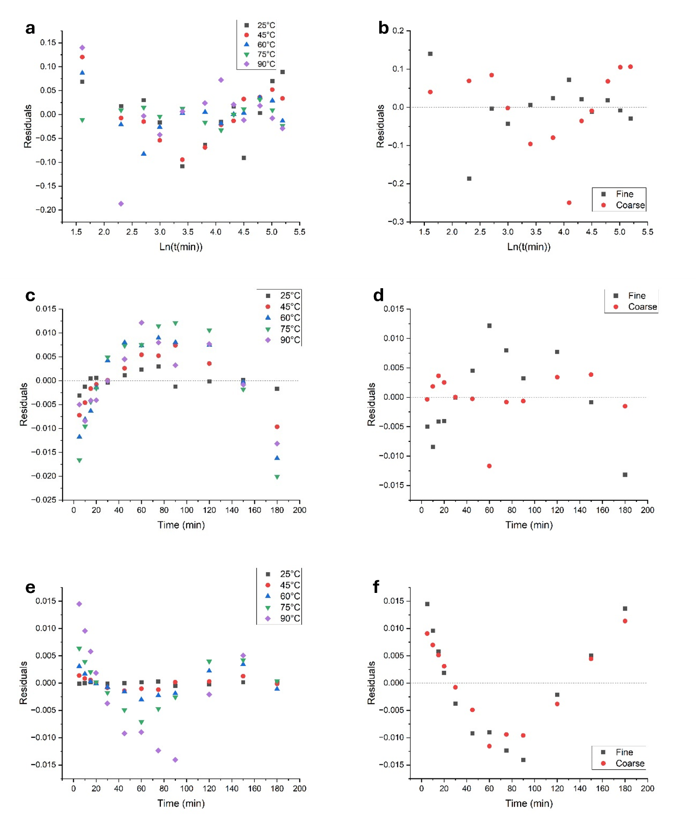
FigureS 1 Residual distributions for the applied kinetic models for wet wollastonite carbonation. Panels (a), (c), and (e) show the residuals for the temperature-dependent dataset at 25°C, 45°C, 60°C, 75°C, and 90°C, while panels (b), (d), and (f) show the corresponding residuals for the particle-size comparison of fine and coarse wollastonite at 90°C. The rows correspond to the Avrami model (a, b), shrinking-core model (SCM) surface chemical reaction control (c, d), and SCM diffusion control (e, f). These plots provide a supplementary assessment of model adequacy and the distribution of deviations between experimental and fitted values.
TableS 6Segmented Arrhenius parameters calculated from the temperature-dependent rate constants of the SCM surface-reaction, SCM diffusion, and corrected Avrami models. The table reports apparent activation energies Ea​, regression coefficients, slopes, and intercepts for the three temperature intervals: Stage I (25–45)°C, Stage II (45–75)°C, and Stage III (75–90)°C. Note that R²=1 for two-point intervals and should not be overinterpreted.

Model | Stage | Ea (kJ mol-1) | R² | Slope | Intercept
SCM surface reaction | Stage I: 25–45 °C | 49.830121 | 1.000000 | -5993.519500 | 11.462640
SCM surface reaction | Stage II: 45–75 °C | 22.987223 | 0.997603 | -2764.881287 | 1.324596
SCM surface reaction | Stage III: 75–90 °C | 11.231160 | 1.000000 | -1350.873222 | -2.747969
SCM diffusion | Stage I: 25–45 °C | 81.522748 | 1.000000 | -9805.478423 | 22.536293
SCM diffusion | Stage II: 45–75 °C | 39.206041 | 0.997449 | -4715.665211 | 6.555945
SCM diffusion | Stage III: 75–90 °C | 11.220027 | 1.000000 | -1349.534187 | -3.132164
Avrami corrected k=(ka)^{1/n} | Stage I: 25–45 °C | 176.434880 | 1.000000 | -21221.419275 | 59.855771
Avrami corrected k=(ka)^{1/n} | Stage II: 45–75 °C | 45.346337 | 0.985487 | -5454.214222 | 10.346163
Avrami corrected k=(ka)^{1/n} | Stage III: 75–90 °C | 12.214421 | 1.000000 | -1469.138919 | -1.154350

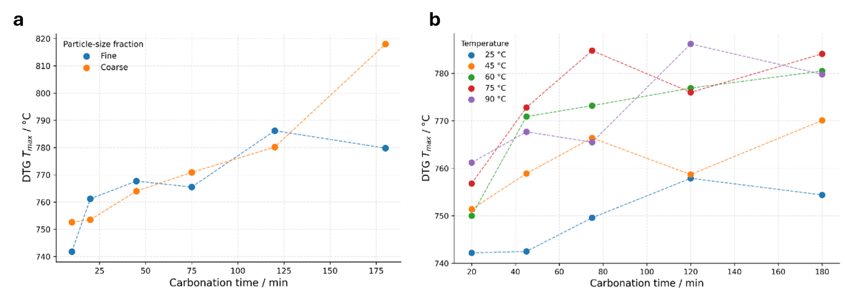
FigureS 2Time-dependent variation of the DTG decomposition maximum temperature (T(DTGmax)) during wet wollastonite carbonation: (a) comparison of fine and coarse wollastonite at 90°C, and (b) carbonation at 25°C, 45°C, 60°C, 75°C, and 90°C. The plots show differences in carbonate-product development and indicate progressively increasing thermal stability of the carbonate phase with reaction time, temperature, and particle-size fraction.

