XRD patterns of (a) CuO and (b) Ga₂O₃

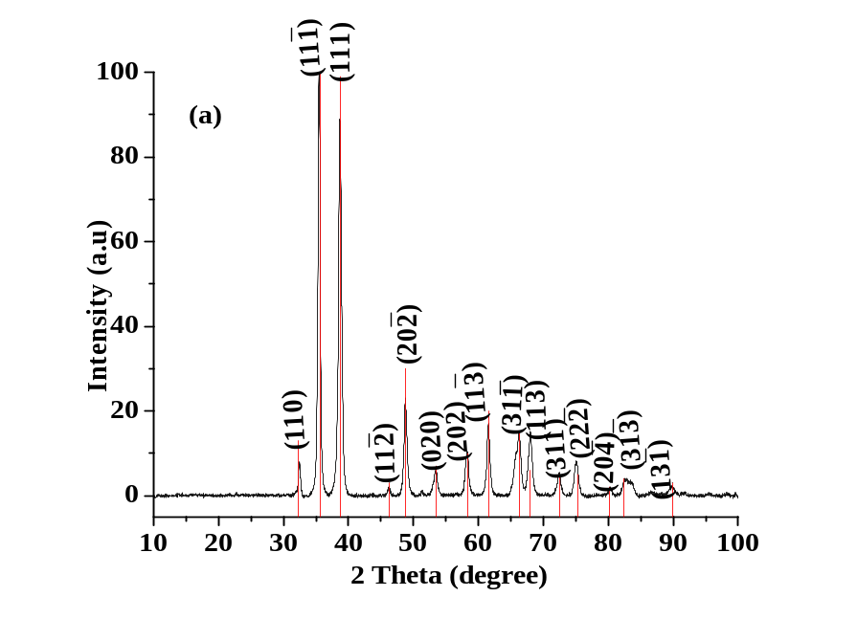
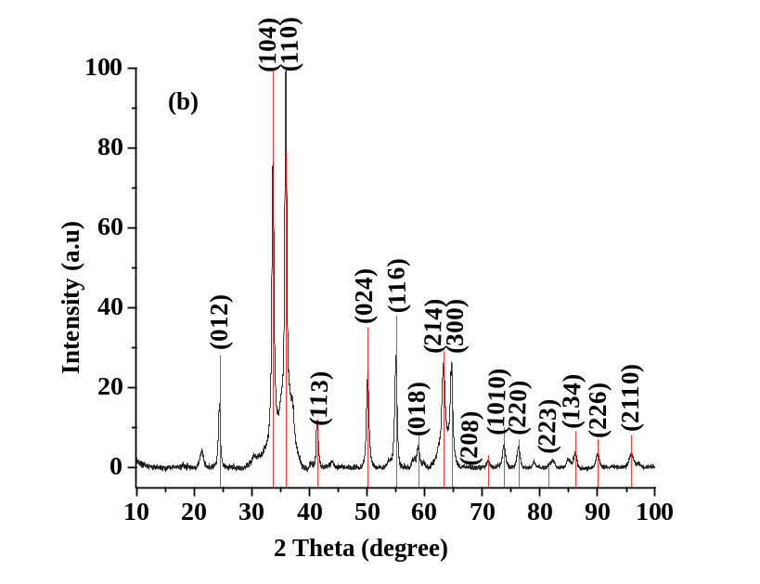
Fig. S3 XRD patterns of (a) CuO and (b) Ga₂O₃

